TE430 – Art Integrated Lesson Plan: Exploring the Great Depression - Written by Joni Starr
“I can” objectives:
- I can identify some causes and consequences of the great depression.
- I can recognize the cultural and economic movement from prosperity to depression.
- I can capture and express feeling through tableaux.
- I can depict characters through improvisation.
- I can discuss the great depression in human terms.
Grade: 9th Time: 75-85 minutes
Michigan Curricular Connection:

Social Studies
7.1 Growing Crisis of Industrial Capitalism and Responses
Evaluate the key events and decisions surrounding the causes and consequences of the global depression of the 1930s and World War II.
7.1.2 Causes and Consequences of the Great Depression
Explain and evaluate the multiple causes and consequences of the Great Depression by analyzing the economic and social toll of the Great Depression, including unemployment and environmental conditions that affected farmers, industrial workers and families.

Theatre
ART.T.I.HS.2 Communicate directorial choices to a small ensemble for improvised or scripted scenes.
ART.T.II.HS.1 Construct imaginative scripts and collaborate with actors to refine scripts so that story and meaning are conveyed to an audience.
ART.T.II.HS.2 Individually and in ensemble, create and sustain characters that communicate with audiences.
Source Materials: http://www.42explore2.com/depresn.htm, http://www.english.illinois.edu/maps/depression/depression.htm, Sally Potter, Economics Teacher, Williamston High School
Teaching Materials: Causes and Consequences information sheets, photographs
Engagement - 15
Introduce tableau with improvisation by modeling an example. (You feel you just did poorly on an exam.) Then, using the following prompts, students create a personal tableau and then bring it to life through improvisation with a partner.
1918: The war has ended and troops are coming home.
1920: You are listening to the first known news radio program broadcast from Detroit on the new radio you just purchased for your home.
1923: You have a job at the new automobile manufacturing plant.
1925: You purchase new appliances for your home on extended credit from the bank.
1927: You are out on the town at a jazz club listening to music and dancing the Charleston.
1929: You learn of the Wall Street Market Crash.
Internal Assessment
- What decade are we focusing on?
- What are some of the events from that decade?
- What is the general mood of the decade? Why?
- What changes the mood at the end of the decade?
- Which tableau did you feel most connected to?
- What about people’s body positions indicated their feelings?
- How did speaking impact the moment?
- Could you imagine stepping into the shoes of those people at that time?
Grouping: individual/partners/whole group Time: 15 minutes Type: Tableaux
Building Knowledge - 20
Define the term “The Great Depression” and introduce some of the general causes and consequences of the historical event.
The Great Depression was a severe economic downturn initiating in the United States in the 1930’s and spreading to many other countries preceding the 2nd World War.
Distribute causes and consequences information sheets (see attached) to students for group discussion and ask them to reflect upon the questions listed on the sheet and to be prepared to share their ideas with the class.
Introduce the Migrant Mother photograph (see notes) and discuss what story it tells. What words does it evoke regarding emotion and mood? What might the back or forward story be of the people in the photograph?
Internal Assessment
- What are some of the causes and consequences of the great depression?
- How did life change from the 20’s to the 30’s?
- What is the general mood of the country in the 30’s?
- How are people feeling in the midst of the great depression?
- What contributed to the nation’s easing of the depression?
- How does the Migrant Mother photograph capture the time?
Grouping: small group/whole class Time: 20 minutes Type: Info Gathering
Explore - 20
Students, working in the same small discussion groups, are given a photograph from the time of the great depression and will follow these steps:
- Write 10 words that describe the photograph, including emotion and mood.
- Define and describe the people in the photograph. Be specific, choose one individual as yourself. What could their/your story be?
- Based on the photograph and using the descriptive words and character information, create an improvised scene, telling a story of the time. Be sure to include all students in the group and construct your scene with a clear beginning and ending. Your scene should reflect the general emotion, character and/or action of the photograph.
Students will end their preparations with a “final rehearsal” to be practiced at the same time.
Internal Assessment
Check in with groups to provide side coaching, assess their understanding and to answer any questions.
Grouping: small groups Time: 20 minutes Type: Artifact Examination/Scenework

Sharing - 10-20
Students will share their work one group at a time while others serve as audience. Ask each group if they wish to share their photograph before or after the scene.
Internal Assessment -
Questions to be asked after each group shares:
- What did you “get” from the scene?
- Are there specific characters? What is the story being told?
- What is the general mood or environment? How did their performance indicate this?
- How did their performance indicate personal feelings?
- Was there an impactful part to perform or observe? Why?
Grouping: performance groups and audience Time: 10-20 mins (depends on # of groups)
Evaluation and Closure - 10
- What were some of the differences between the 1920’s and 1930’s?
- Define the term “The Great Depression.”
- Name two causes of the great depression.
- What happened on Black Tuesday, Oct. 29, 1929?
- What prompted the dust bowl?
- What helped the nation move beyond the great depression?
- How did the mood of the country change between the two decades?
- How did the great depression impact individuals and their lives?
- Do you see any connections between the 1930’s and our lives today?
- How did you construct a scene?
- What performance skills were needed for successful storytelling?
- What occurred during the rehearsal process? Did it come easily or was it challenging? Explain your answer.
- How does theatre help us to better understand others?
Grouping: whole class Time: 10 minutes Type: Discussion
After the lesson students could:
- Research an element of the Great Depression more thoroughly and make a power point presentation about their findings.
- Explore The Grapes of Wrath by John Steinbeck in book, play, or movie format.
- Connect all of the improvised scenes and write more formal scenes to share with others.
- Create a collage of words and images that reflect the time period.

Vocabulary – Social Studies and Theatre
Great depression tableau
Migrant Mother improvisation
Black Tuesday character study
Dust bowl scene work
Notes:
- The Great Depression was a severe economic downturn initiating in the United States in the 1930’s and spreading to many other countries preceding the 2nd World War.
- In October 1929 the stock market crashed, wiping out 40 percent of the paper values of common stock. Even after the stock market collapse, however, politicians and industry leaders continued to issue optimistic predictions for the nation's economy. But the Depression deepened, confidence evaporated and many lost their life savings. By 1933 the value of stock on the New York Stock Exchange was less than a fifth of what it had been at its peak in 1929. Business houses closed their doors, factories shut down and banks failed. Farm income fell some 50 percent. By 1932 approximately one out of every four Americans was unemployed.
- The core of the problem was the immense disparity between the country's productive capacity and the ability of people to consume. Great innovations in productive techniques during and after the war raised the output of industry beyond the purchasing capacity of U.S. farmers and wage earners. The savings of the wealthy and middle class, increasing far beyond the possibilities of sound investment, had been drawn into frantic speculation in stocks or real estate. The stock market collapse, therefore, had been merely the first of several detonations in which a flimsy structure of speculation had been leveled to the ground.
- The photograph that has become known as "Migrant Mother" is one of a series of photographs that Dorothea Lange made in February or March of 1936 in Nipomo, California. Lange was concluding a month's trip photographing migratory farm labor around the state for what was then the Resettlement Administration. In 1960, Lange gave this account of the experience:
I saw and approached the hungry and desperate mother, as if drawn by a magnet. I do not remember how I explained my presence or my camera to her, but I do remember she asked me no questions. I made five exposures, working closer and closer from the same direction. I did not ask her name or her history. She told me her age, that she was thirty-two. She said that they had been living on frozen vegetables from the surrounding fields, and birds that the children killed. She had just sold the tires from her car to buy food. There she sat in that lean- to tent with her children huddled around her, and seemed to know that my pictures might help her, and so she helped me. There was a sort of equality about it. (From: Popular Photography, Feb. 1960).

1920’s | 1930’s
After World War I, the 1920’s was a flourishing time with heavy manufacturing, expansion of agriculture and high investment. | The ensuing period ranked as the longest and worst period of high unemployment and low business activity in modern times.
People were buying electric washing machines, toasters, and cars on extended credit from banks. | Banks, stores, and factories closed and left millions of Americans jobless, homeless, and penniless. Many became migrant farm workers and lived in tent camps.
Soon consumers became overextended in their credit while also quickly becoming cashless. | The major US business was agriculture and it was expanding at great speed thus creating overexpansion. Farmers continued to move west and ended up digging in the sand for planting, thus contributing to the great dust bowl that adversely affected the nation.
Businesses were over expanded and there was no customer base. With businesses overproducing and no reliable customer base, layoffs were imminent. | The drought that helped cripple agriculture in the Great Depression was the worst in the climatological history of the country. By 1934 it had desiccated the Great Plains, from North Dakota to Texas, from the Mississippi River Valley to the Rockies. Vast dust storms swept the region.
People and businesses couldn’t pay their bank loans. | Many people came to depend on the government or charity to provide them with food.
The government acted as isolationists by creating barriers to trade and the US was unable to sell abroad. Ultimately too many products flooded the US market and prices began to drop but at this point people couldn’t buy. | Franklin D. Roosevelt was elected President in 1932. Roosevelt's 'new deal' reforms gave the government more power and helped ease the depression.
On Black Tuesday, October twenty-ninth, the market collapsed. In a single day, sixteen million shares were traded--a record--and thirty billion dollars vanished into thin air. Westinghouse lost two thirds of its September value. DuPont dropped seventy points. The "Era of Get Rich Quick" was over. | The Great Depression ended as nations increased their production of war materials at the start of World War II. This increased production provided jobs and put large amounts of money back into circulation.

- What are some of the causes and consequences of the great depression?
- How did life change from the 20’s to the 30’s?
- What is the general mood of the country in the 30’s?
- How are people feeling in the midst of the great depression?
- What contributed to the nation’s easing of the depression?

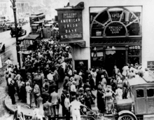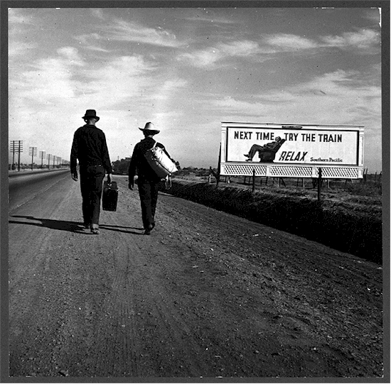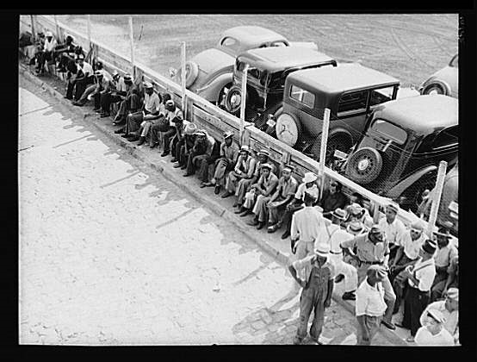
(left) Crowd at New York's American Union Bank during a bank run early in the Great Depression.
(middle) People left their homes to find work or a better life.
(right) Unemployment lines.
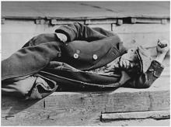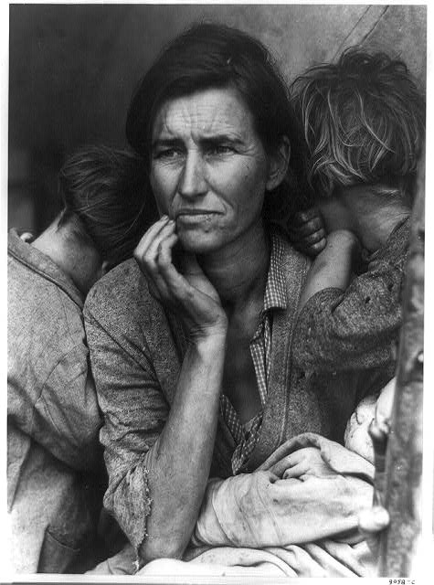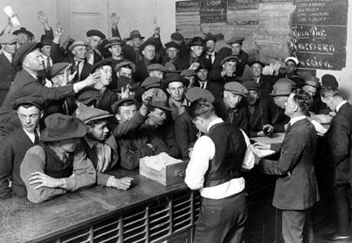
(left) Man lying down on pier, New York City docks, 1935
(middle) Migrant farm family living in a tent.
(right) Men vying for work at the unemployment office.

