SIOP MODIFIED LESSON PLAN
Exploring Simple Machines
Rachel Sanborn (2016)

BACKGROUND
Context: | U.S. Public School, mainstream classroom with high numbers of ELLs, Mid-school year
Intended  Student Demographics: | Ages: 8-9 year old  Grade: 2nd-3rd grade  Language: Mix of native English Speakers and English Language Learners  Class size: About 16 (lesson can be modified accordingly)
Proficiency Levels: | intermediate mid – intermediate high  Although proficiency levels vary, most English Language Learners are intermediate mid – intermediate high. Speakers are able to converse with their 2nd-3rd grade peer Native English speakers with ease and confidence when dealing with routine tasks and social situations, although some are able to handle less complicated communicative tasks easier and are able to express personal feelings more fluently but speech may “contain pauses, reformulations, and self-corrections as they search for adequate vocabulary and appropriate language forms to express themselves”. They are able to meet all practical writing needs and although some have more difficulty then others, are able to write simple summaries. Students in intermediate mid-intermediate high are able to use listening skills to understand simple sentence-length speech and “derive substantial meaning from some connected texts” although there are often gaps in understanding due to limited knowledge of vocabulary and structures of the spoken langue. As readers, students at this proficiency level are able to understand fully and with ease “short, non-complex texts that convey basic information” although there is also occasional gaps in understanding.  https://www.actfl.org/publications/guidelines-and-manuals/actfl-proficiency-guidelines-2012/english
Course Content Area: | Science
Texts/Materials: | Classroom Computers  https://www.tes.com/lessons/X-Yflt30g_d_IA/simple-machines (Videos as input to introduce the topic → although all 6 simple machines are included on this website, students will be instructed to watch 2 of them per lesson. Lower level learners will be watching the videos and taking notes.)  http://teacher.scholastic.com/dirtrep/simple/invest.htm  (Higher Level Learners will be reading and taking notes)  Printed Graphic organizer (see end of document)  Lab guide (see end of document)  Pictures of real life examples of pulleys and inclined planes (see end of document)  Workshops  - Textbooks, ruler, stool with various steps, larger flat board, small scale pulley, paper clips, large scale pulley, various items to use at stations (weights, pencils, pens, keys, pillows, toy cars, etc.)
Lesson length: | About 60-90 minutes, 1-2 class periods (includes intro to simple machines, and learning about 2 simple machines in-depth. This lesson is planned to be retaught similarly 3 times, each lesson going into depth about 2 simple machines until all the simple machines are taught)
Previous classwork / background knowledge: | Previously, the class has worked on vocabulary necessary to understand simple machines (such as friction, weight, machine, work, force, etc.). Students also have been in this classroom for more than a month, so they understand the teacher’s classroom set up and the general routines involved in science demonstrations/experiments. Students have been introduced to various graphic organizers throughout the class thus far.
OBJECTIVES
Content Objectives: | 1. Students will be able to list 2 of the 6 simple machines (pulley and inclined plane out of pulley, inclined plane, screw, wedge, lever, wheel and axle)  2. Students will be able to explain how the two simple machines covered in the lesson are used in everyday life to make work easier (in this edition, pulleys and inclined planes).  3. Students will be able to list 3 examples of a pulley and 3 examples of an inclined plane.  4. Students will be able to use a physical model of the two machines learned in lesson in order to make observations on the changing difficulty of moving objects from not using the simple machine(s) to using it.  Somewhat based off of the Michigan State Common Core for 2nd and 3rd grade science/engineering design:  - K-2-ETS1-1 Ask questions, make observations, and gather information about a situation people want to change to define a simple problem that can be solved through the development of a new or improved object or tool.  - K-2-ETS1-3 Analyze data from tests of two objects designed to solve the same problem to compare the strengths and weaknesses of how each performs.  - K-3-5-ETS1-2 Generate and compare multiple possible solutions to a problem based on how well each is likely to meet the criteria and constraints of the problem.
Language Objectives: | - They can use speaking and listening skills in order to participate in a class discussion providing observations and thoughts on workshop findings.  - Students will be able to use their writing skills to write the definition of a pulley and an inclined plane.  - Students will be able to write words on a Venn diagram in order to compare and contrast their thoughts on pulleys and inclined planes.  - Students will be able to effectively communicate their ideas and understandings of their assigned website’s text/video to partner in order to add to their graphic organizers.
PROCEDURES
Timing | Activity and its objective | Step-by-step details | Interaction/ seating
~5 mins | Attention Grabber  (Building background and interest) | Gather the attention of the students, and point to the heavy box on the ground. (A box with books or rocks; something that makes it fairly heavy and difficult to move) Pick a student to try to pick it up. Once the student realize they cannot (or is difficult to) move the box. | Whole Class, front of the room gathered around demonstration
~5-10 mins | Introducing the topic/warm up. | Lead a class discussion over what they just observed (teacher will be writing their answers on the board, wait time will be given sufficiently – especially as the questions have no right or wrong answer). Promote class discussion and allow for students to discuss with and collaborate with each other as well.  Sample questions:  - Did you have an easy or hard time moving that box?  - Why do you think the box might have been so hard to move?  - Is there something that could help you move that box? | Whole Class, in desks but engaged in class conversation
~5 mins | Explain agenda and content/language objectives for the lesson | Cover the following while using a visual list at front of classroom for student reference  Agenda:  - Class review  - Class lesson  - Independent reading/watching from websites (fill out graphic organizer)  - Discuss, compare graphic organizers with a partner)  - Experiments, in groups (fill out lab guide on back of graphic organizer)  Objectives: (see both content and language objectives above)  (refer to the visual posting of objectives on the front board for students’ reference)  Tool box: there is a toolbox posted in the room with ideas for help if a student is confused or doesn’t understand their task or text. Tools include: Rereading, using context clues, asking a peer for help, asking teacher for help, using online search engine to look up definition, referring to notes from previous class session, etc. | Whole Class, in desks
~5 mins | Revisiting previous learned information and introduce some more | Review the vocabulary that was previously learned (Friction, weight, force, machine, work). Refer to the class word bank of accumulated terms learned throughout the class hanging on the wall.  Although discussed in previous class, review the concepts relating to force being exerted but not necessarily resulting in an object’s movement (and for “work” to be done, there must be motion, as work=force x distance).  Also review concept that simple (and compound) machines can be used to make work easier to do. We use them all the time!  - Show various real-life use of simple machines (see corresponding visuals at end of document)  - Pulleys: window blinds, ship sails, flag poles, cranes, elevators, etc.  - Inclined Planes: ramps, slides, wheel chair ramps, etc.  - Modified Inclined Planes: stairs, escalators, ladders, walking paths  Relate this back to the “box” demonstration, and introduce the six simple machines. Play the Simple Machine song for the whole class  Song: https://www.tes.com/lessons/X-Yflt30g_d_IA/simple-machines | Whole Class, in desks with school laptops (or in computer lab)
~5-10 mins | Learning information about 2 of the 6 simple machines | Separate the class into two different groups, based on proficiency level. Lower level learners will be watching the videos from tes.com and taking notes on the graphic organizer (watch only the pulley and inclined plane videos). While the Higher level learners will be reading about 2 of the simple machines from teacher.scholastic.com and taking notes on the graphic organizer (read the simple machines introduction and the short paragraph for the pulley and inclined plane only).  https://www.tes.com/lessons/X-Yflt30g_d_IA/simple-machines  http://teacher.scholastic.com/dirtrep/simple/invest.htm  (see end of this document for graphic organizer) | Two different groups. But working individually.
~5 mins | Compare and contrasting. | Pair the students up in groups (1 lower level, 1 high level). Compare and contrast graphic organizers to ensure both have the correct information. Students may use websites as reference to reread or rewatch videos. | Pair work, at computers sitting next to each other
~5 mins | Regather, explain workshops | Introduce the workshops while using gestures and moving between stations to explain each one. Allow for questions after each station and check for understanding by asking for a “thumps up, thumbs down, or thumbs sideways” indicating how well they understand what to do at the station.  Students will be doing these simultaneously with their partner and one other group (about 4 students per group)  Each group will explore a station for 3 minutes until teacher says switch.  Each station has various simple machines (in accordance to the 2 machines covered in the lesson, this lessons include pulleys and inclined planes). There are 4 stations total, 2 stations contain pulleys and 2 contain inclined planes. There are various objects at each station that students can attach to pulleys or use on inclined planes to experience hands on supplementation of their learning)  Students will be given a lab guide (see end of document) to fill out as they switch between stations | Sitting with partner, listening to teacher
~20 mins  (5 minutes per station) | Workshops | Workshops  Station 1: Pulley, small scale, a paper clip is attached to end of pulley along with various items to attach to paper clip such as pens/keys/mini weights/etc.  Station 2: Pulley, large scale, box attached to pulley (from demonstration) and various items to place in box such as books/weights/pillows/etc.  Station 3: Inclined plane, small scale, includes textbooks (students can add textbooks to change height) with ruler leaning on them and various small items to push up/down the ruler ramp such as toy cars/pencils/etc.  Station 4: Inclined plane, large scale, large flat piece of wood leaning on a stool with multiple steps (students can change the height) includes bigger items such as books/square weights/etc.  Teacher is circulating around to groups, pointing out more in-depth observations such as changing the height of an inclined plane impacts the speed of an object going down and difficulty of pushing an object up, etc. Teacher is also spot checking how students are figuring out how to use the machines and observing them filling out the worksheets. | Small groups, stationed around room
~10  mins | Review and assessment | ● Review content and language objectives  ● Allow students to self-assess if they’ve met the objectives (will gather graphic organizers and lab guide at end of lesson for teacher assessment)  ● Review learned vocabulary while discussing the following. Students will be asked to give definitions of the vocabulary as they use it in their descriptions.  ● Discuss interesting observations (refer to lab guide)  ● Reconnect to daily lives, point out various real-life situations where we use these simple machines  ● Open floor to lingering thoughts or questions  Teacher will collect graphic organizers and lab guide at end of period and review them, giving feedback and returning them the next period. This will also provide an opportunity to review the lesson before beginning a new one. | Whole class, students at desks
Contingency Plans and Other Notes (optional):
- This lesson can be repeated similarly for the other 4 simple machines
- Provide simple instructions for each station with demonstration pictures depending on class proficiency levels
- Different input methods allow for more differentiation in lesson, videos and visuals can better help lower level proficiency students with comprehension and a text-based source may help challenge high level proficiency students.
SIOP LESSON PLAN RATIONALE
Introduction to the Course, Students, and Objectives.
This lesson plan was created with the demographics of around 16 students of 8-9 year olds in 2nd-3rd grade in a U.S. Public School in Michigan, the time of the lesson is mid-school year when students have become adjusted to the teacher, classmates, and basic procedures/rules expected. The intended students are partially native English speakers with a few English Language Learners who have various language proficiencies although most ranging around intermediate mid and intermediate high. Content objectives are loosely based off of the 2nd and 3rd grade Michigan Science Common Core and involve being able to list 2 out of the 6 simple machines, explain how they are used to make work easier, list 3 examples of each a pulley and inclined plane, and be able to use a physical model of each machine (see lesson plan for Common Core standards used). Language objectives involve writing, reading, speaking, and listening skills as they are asked to compare/contrast different machines, participate in class discussions, and write on graphic organizer and lab guide.

Lesson Preparation.
As stated in lesson plan, agenda and objectives are explained and posted in front of the classroom. This allows for a better understanding of what students are expected to gain from the lesson and are readily available for students to reference throughout the day. Supplementary material varies based on language proficiency; however, both website sources include pictures along with text. The lesson provides various opportunities to work with partners/groups in order to check comprehension of individual research on the two simple machines. With this peer work time, students are able to get and give help filling in gaps on their graphic organizer and assist each other in understanding what they have read/watched.

Building Background.
As described in lesson plan, students have previously learned various vocabulary words through direct teaching (which also are posted on the wall with simple definitions and are reviewed again during lesson) corresponding with the lesson and also have been enrolled in the class for more than and have a solid foundation of expectations and routines the teacher implements as well as have used simple graphic organizers and Venn diagrams in class before (Folse). The demonstration at the beginning of the lesson provides an opportunity to link students’ background knowledge (from both in and outside of classroom) and to see visual usages of the pulley and inclined plane.

Comprehensible Input.
Speech within video and text on websites is simple and supplemented with visuals (Echevaria). Teacher.scolastic.com provides slightly more difficult sentences then tes.com’s videos in order for differentiation and a challenge to students who are more proficient. A clear explanation of academic tasks is given at the beginning of lesson as both agenda and objectives are stated clearly as well as posted. A variety of techniques are used to make content concepts clear such as demonstrations, text and visuals on websites, hands-on workshops, and group work.

Strategies.
Opportunities are provided for students to use learning strategies as they take notes on a graphic organizer while exploring websites and students are reminded of the “tool box” posted on a wall in the classroom with strategies for when a student feels confused or doesn’t understand a text (see lesson plan for tool examples).Scaffolding techniques are also used in order to support student understanding as first the class works together to introduce topic, individual work is followed by partner discussions, then merged into groups. Students experience gradual release while also working with peers as hands-on demonstrations are introduced and instruction may be more confusing. This peer collaboration promotes higher-order thinking skills as students must interpret their own understanding and also get/give help from/to other peers for better understanding.

Interaction.
Frequent opportunities for interaction between both teacher/student and student/student are given during whole class demonstrations and discussions as well as peer work. Teacher is readily available to act as a “tool” if students need assistance both during individual work time and group work in stations. Higher and lower proficiency students are paired which allows for lower proficiency students to get help through a one-on-one interaction and higher proficiency students to better their own understanding by challenging them to explain and express their own understanding in simple manners to their partner. This opportunity for students to clarify key concepts is beneficial, and once in groups of 4 students with lower proficiency will also have opportunity to clarify with their L1 if necessary. Additionally, wait time is given during each point where the class comes together.

Practice/Application.
As indicated in lesson plan, various hands-on materials are provided for students to practice using pulleys and inclined planes during workshop time. They are able to apply content knowledge through these workshops, and also apply language knowledge while working with their peers in small groups. This lesson integrates all language skills as students must read independently (with the help of visuals) from websites, write notes on a graphic organizer, listen to their peers, and effectively speak in order to share their own understanding with peers.

Lesson Delivery.
Content and language objectives are gradually achieved throughout the scaffolded lesson, and although students’ engagement varies between listening/responding to teacher, reading/watching, filling out a graphic organizer, discussing with peers, and using physical models of pulleys and inclined planes in workshops; students are engaged more than 90% of the period. The pacing of the lesson is appropriate to students’ ability levels as differentiation is provided through multiple comprehensible inputs and multiple opportunities to clarify and enhance understanding are provided.

Review & Assessment.
After workshops, the class regathers and reviews content and language objectives. They are given the opportunity to self-assess if they’ve meet the objectives, while the later turned in graphic organizer will help the teachers make their own assessment. A review of the key vocabulary and key content concepts is conducted again, this time allowing students to give definitions rather than having the discussion teacher focused. Throughout the lesson, regular feedback is provided to students on their output as peers assess and progress the understanding of their partners/groups and teacher responds to oral output during the class review. Students are also assessed on their comprehension and learning of lesson objectives as teacher travels around the room during individual work time while spot checking students filling out graphic organizers and during workshop time while teacher walks around room. Teacher also provides self-assessment during the review at the end of the period and allows group responses for understanding of what to do during tasks during lesson introduction. Teacher will also provide individualized feedback on graphic organizers for the next class period which may be used as a review of the lesson before moving to next lesson.

Effectiveness and Appropriateness of the Lesson Overall.
Overall, this lesson is appropriate for the age level and students targeted especially as differentiation is implemented through a variety of comprehensible inputs and partnerships are carefully considered based on proficiency level of each learner. The objectives are based off of the Michigan Common Core for Science, and are in line with 2nd and 3rd grade content goals. Some freedom is given during workshops, but the lesson is structured enough for 8-9 year olds to stay productive and on task. This lesson is also effective as it incorporates the eight models of The Sheltered Instruction Observation Protocol while emphasizing on opportunity for effective communication between peers and with teacher and on easily accessible and usable visuals to supplement learning (Echevaria). Finally, this lesson is effective for future lessons as it can be easily modified to teach the other 4 simple machines. With these factors all aligned, this lesson proves to be effective and appropriate (Mihai).

References
Lesson plan template adapted from Purgason, K. (2014). Ch 23: Lesson planning in SL/FL teaching. In Celce-Murcia, M., Brinton, D., & Snow, M.A. (Eds.), Teaching English as a second or foreign language (4th ed.) (pp. 362-379). Boston, MA: Heinle.

Echevaria, J., Vogt, M., & Short, D. (2008). Making content comprehensible for English language learners: The SIOP Model. New York: Pearson/Allyn and Bacon.

Folse, K. S. (2004). Vocabulary myths: Applying second language research to classroom teaching. Ann Arbor, US: University of Michigan Press.

Mihai, F. (2014). Assessing English language learners in the content areas: A research-into-practice guide for educators. Ann Arbor, US: University of Michigan Press.

Proficiency levels based off https://www.actfl.org/publications/guidelines-and-manuals/actfl-proficiency-guidelines-2012/english
Websites: https://www.tes.com/lessons/X-Yflt30g_d_IA/simple-machines, http://teacher.scholastic.com/dirtrep/simple/invest.htm

Graphic Organizer
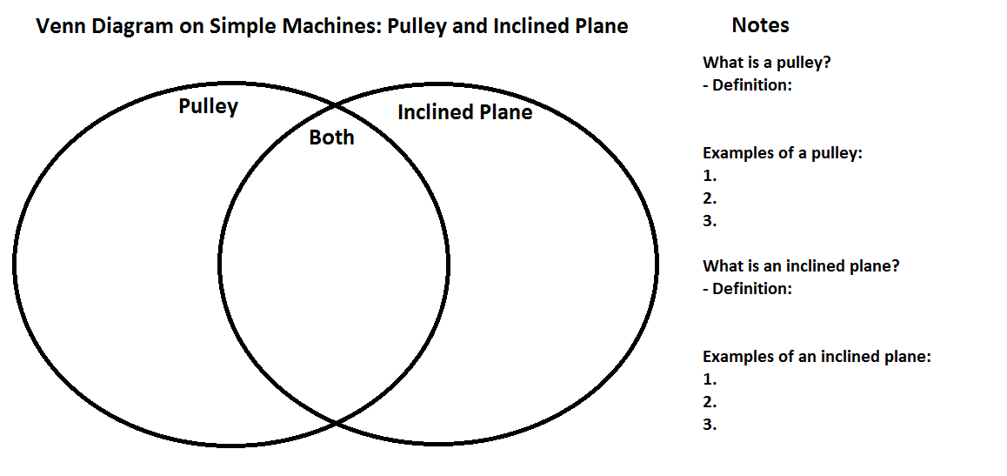
Lab Guide
Pulleys:
- Which object was more difficult to lift?
- Which object moved easiest?
- When you pulled faster what happened differently (if anything)?
- What do you think would happen if you used different types of rope? (hint: think friction)
- Other observations (optional):

- What problem does this simple machine help solve?
Inclined Planes:
- Which object was more difficult to move?
- Which object moved easiest?
- What happened when you added textbooks to where the ramp was leaning on?
- What happened when you took away books from where the ramp was leaning on?
- Other observations (optional):

- What problem does this simple machine help solve?
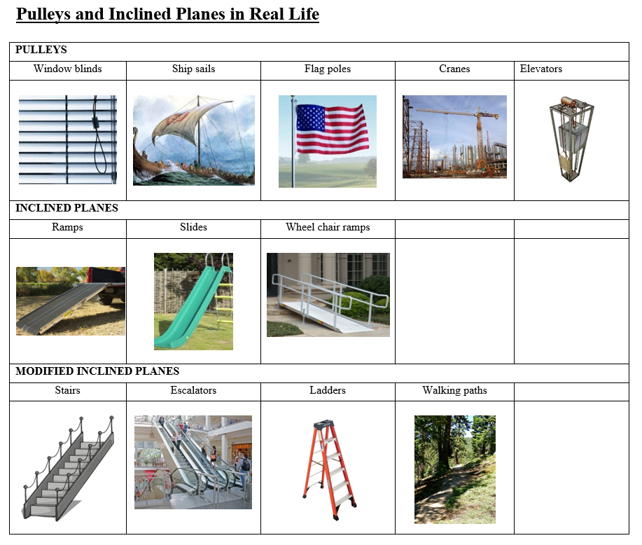

Extra Material (Optional)
