**Rachel Sanborn**

**Physical Activity and Health Education**

**Lesson Plans and News Letter Examples**

**(2015)**

**Table of Contents**

**Lesson Plans**

* “Super Spartan, What Time is It?”

– Rachel Sanborn

* “Hidden Germs”

– Rachel Sanborn

* “Word/Definition Matching Expedition”

– Rachel Sanborn

* “Natural Disaster”

– Megan Nicholson

* “Couch Potato”

– Kiersten Rutherford

* “Around the World”

– Skylar Corey

* “Even/Odd Number Jump”

- Megan Nicholson

* “Move Like Matter”

– Laura Cosentino

**Newsletters**

* “Fighting Obesity”

- Rachel Sanborn

* “Nutrition Outside the Classroom”

– Kendra Bennett

**Annotated References**

* Annotated Reference One
* Annotated Reference Two
* Annotated Reference Three
* Annotated Reference Four
* Annotated Reference Five

**LESSON PLANS**

|  |  |  |  |  |  |  |  |  |
| --- | --- | --- | --- | --- | --- | --- | --- | --- |
| ***Super Spartan, What Time is It?***  Date created created: 10/6/15 | | | | | **Teacher: Miss Rachel** | | | |
| **School: MSU Elementary** | | | |
|  | | | | | | | | |
| Grade Level: Any  Time: 30 minutes  Number of Students: 5+ | | | Equipment:  Gym lines | | | | | |
| Targeted NASPE Standard(s): NASPE Standards 1, 2, 3, 4, 5 | | | | | | | | |
| Specific Objective: By the end of this lesson, the students will be able to listen to directions from both the teacher and other students. They will learn that it’s not only important to listen to your teacher, but also important to listen and be respectful to your peers. This will be assessed by observation, listening, and review at the end.  Concomitant Objective: The students will stay physically active while having fun. | | | | | | | | |
| **Time** | **Procedures Followed** | | | | | | **Materials** | |
| **N/A Minutes** | **Warm Up: NONE NEEDED** (Because students are not exerting tons of energy and are taking many breaks between the energy that they are exerting. The activity is also so short with small bursts of running, that it almost feels like a warm up itself.) | | | | | |  | |
| **2 Minutes** | **Transition:**   * *When I say “GO GREEN”, students stop what they’re doing, look at me, and say “GO WHITE”.* * Practice the stop protocol. * When I say so, students line up alone line. * Set introduction given there. | | | | | |  | |
| **2 Seconds** | **Set Induction:**   * *With toes on gym line* * *Who knows who our school mascot is?* * *That’s right! It’s Spartan.* * *Today we’re going to play a game where one person is Super Spartan!* * -Explain Learnable Piece | | | | | |  | |
| **2**  **Seconds** | **Learnable Piece:**   * *You will be learning how to listen to not only the teacher, but also each other.* * *This includes not talking with the teacher is talking or when one of your classmates are talking* | | | | | |  | |
| **2 Minutes** | **Presentation of New Material/Directions:**   * Show demo (entire class participation) while explaining. * Similar to “Cookie Monster” game. * 1 student in the middle of the court (Super Spartan), with the rest of the students standing in a line by the wall.   (“Super Spartan, what time is it?”)   * Super Spartan can shout any number between 1 and 12.   (“It’s __ time!”)   * Class, in unison, takes that many steps towards the other side of the gym (steps will vary depending on step size). * As class approaches Super Spartan by continuing to ask “Super Spartan, what time is it?” Super Spartan will randomly reply “It’s Spartan time!!” * When this is said, all students will run back to the wall (safety) while Super Spartan tries to tag one of them. * Student who gets tagged will be the new Super Spartan. * SAFETY:   + There will be lots of movement as everyone is running back to safety wall, so you need to watch out for your neighbors.   + Super Spartan must tag someone gently, no pulling or grabbing. * Checking for Understanding:   + What do the students ask Super Spartan?     - “Super Spartan, what time is it?”   + What to do when Super Spartan says “It’s Spartan Time!”     - Run back to the wall. | | | | | |  | |
| **20 Minutes** | **Guided Activity Time with Corrective Feedback:**  **Transition:**  After about 5 minutes, use stop protocol (“Go Green”-“Go White”)  Student’s circle up at end of game. | | | | | |  | |
|  |  | | | | | |
| **N/A Minutes** | **Possible Modifications:**   * If Super Spartan can’t tag anybody, then they may choose a student to be the new Super Spartan. * If game is too easy, rather than stepping forward, they could do a different action (jump, hop, skip, etc.) | | | | | |  | |
| **2 Minutes** | **Lesson Review/Checking for Understanding:**   * **Questions:**   + Who got to be Super Spartan today?   + How did it feel when everyone was being quiet and listening to you?   + Did you feel respected?   + Teacher: Focus on learnable piece above.     - We learned to listen to not only the teacher, but also to our other classmates**.** | | | | | |  | |
| **Notes** |  | | | | | |  | |
|  |  | | | | | |  | |
| ***Hidden Germs***  Date created created: *11/10/15* | | | | | | | **Teacher: *Miss Rachel*** | | | |
| **School: MSU Elementary School** | | | |
|  | | | | | | | | | | |
| Grade Level: Middle School  Time: 30-40 minutes | | | | | Equipment Used:  5 Hula Hoops | | | | | |
| Targeted NASPE Standard(s): 1, 2, 4, 5, 6 | | | | | | | | | | |
| Specific Objective: *By the end of this lesson, the student’s will be able to answer the following questions: “Do you always know where the germs are?” (answer: no, they could be anywhere) “What is one thing you can do to stay healthy?” (Answer: wash hands). Students will then be able to implement their learned experience of the importance of washing hands in their own lives. This will be assessed by asking these specific questions at the end of the lesson.*  Concomitant Objective: *Students will stay physically active* | | | | | | | | | | |
| **Time** | | | **Procedures Followed** | | | | | | **Materials** | |
| **3 Minutes** | | | **Warm Up:** *not needed, movement in this lesson will not be intense or put any muscles at risk of being pulled, etc.* | | | | | |  | |
| **2 Minutes** | | | **Transition:**  *When I “GERMS” you say “EWW!” (practice this)*  *Line up along the green line* (give set intro here) | | | | | |  | |
| **5 Minutes** | | | **Set Induction:**   * *Who has been sick before or maybe even is sick now?* * *The cold season is starting to come around, what are some things we can keep ourselves from getting sick?* * (they may answer some different things) * *Today we are going to play a game that will help us learn that washing our hands is important to get rid of the germs that make us sick.* | | | | | |  | |
| **30 Seconds** | | | **Learnable Piece:**   * *We will play this game and learn that germs can be hiding anywhere, and since we don’t always know who is sick, we need to always wash our hands just in case.* | | | | | |  | |
| **5 Minutes** | | | **Presentation of New Material/Directions:**   * Students will listen to the activity and stay in their location until I say go. * *USE A DEMONSTRATION* * *Everybody will move around the room* * *Music stops🡪 run to a sink (hula hoop) and wash your hands trying not to get touched by anybody (ONLY 4 KIDS PER SINK-1 FOOT IN)* * *If someone touches you, then you are now sick so you need to run and give me a high five so that you can be healthy again* * *(If you’re a germ, when the music stops, you’re trying to tag as many students as you can before they make it to wash their hands.)* * SAFETY-if you’re a germ, be careful when you’re tagging kids because we don’t want to hurt each other. Be careful when running to the sinks so that you don’t run into your neighbors   *(Explain as it’s happening) – How we are choosing germs*   * *Everybody close their eyes and hold out their hands* * *If you feel your hand get touched, open your eyes, but don’t make any noise. You are a germ.* * *Look around to see who else are germs. Don’t tell anybody or give away that you are one (this is secret)* ***because we don’t always know who has germs or who are sick. They’re hidden amongst us.*** * *When I say open, everybody will open their eyes*   Understanding check:  “If you’re a healthy kid, what do you do when the music stops?”(run to the sinks-hula hoops- to wash your hands)  “If you’re a germ what do you do when the music stops?” (try to tag healthy kids before they get to the hula hoops)  “What do you do if you get tagged?” (Come give me a high five) | | | | | |  | |
| **30 Seconds** | | | **Transition:** *When I say go, everybody spread around the gym* | | | | | |  | |
| **20 Minutes** | | | **Activity:**  x x x O x x x O x x x x  *x x x x x x x x*  *O x x* x *x O x x O x x O x*  *ME (with laptop/music)* | | | | | |
|  | | |  | | | | | |  | |
| **N/A Minutes** | | | **Possible Modifications:** *this game is meant to have very short rounds. Once the first round is over, everybody will close their eyes and the original germs will each chose one more person to also be a germ with them*  During later rounds, students can jump, skip, hop rather than just move around. | | | | | |  | |
| **2 Minutes** | | | **Lesson Review:**  Did everybody have fun?  Did we learn some stuff about staying healthy today?  *“Do you always know where the germs are?” (answer: no, they could be anywhere)*  *“What did we learn to do in order to stay healthy?” (Answer: wash hands).*  *I hope everybody keeps washing their hands and stays healthy despite this cold season!*  *Have a great day!* | | | | | |  | |
| **Notes:** | | | | | | | | | | |

|  |  |  |  |  |
| --- | --- | --- | --- | --- |
| ***Word/Definition Matching Expedition***  Date created created: 12/3/15 | | | **Teacher: Miss Rachel** | |
| **School: MSU Elementary** | |
|  | | | | |
| Grade level: any (adapt material accordingly)  Time: 15-20 minutes | | Equipment: vocab words, paper | | |
| Targeted NASPE Standard(s): NASPE Standards 1, 2, 4, 5, 6 | | | | |
| Specific Objective: By the end of this lesson, the students will be able to demonstrate the ability to correctly definitions for our current vocabulary list.  Concomitant Objective: The students will stay physically active. | | | | |
| **Time** | **Procedures Followed** | | | **Materials** |
| **_N/A__ Minutes** | **Warm Up:** NONE NEEDED | | |  |
| **__10___ Seconds** | **Transition:**   * Students sitting at their seats to begin. * “Lights off, voices off” | | |  |
| **1**  **Minute** | **Set Induction:**   * Today you are going to continue to work with our vocabulary words. * Quick review the words:   + (read list of words)   + They should already know the words because we’ve been working on them in class for the past few days. | | |  |
| **1-2**  **Minutes** | **Learnable Piece:**   * We’re going to do an activity that gets us up and moving. Each student will get either one of our vocabulary words or a definition of one of them.   (pass this down each row while talking)   * You’re goal in this activity is to find your definition (if you have a word) or find your word (if you’re a definition) * If you run into the wrong match, help them out with what you think their match might be. * There are multiple of each word and definition. So if somebody else with the same card finds your match before you, don’t worry, yours is still out there. * SAFETY: We’re going to do this walking, since it’s a small room and I don’t want anybody getting hurt. Watch out for other people, stairs, and backpacks. * (Even just walking is physical activity and it helps you stay healthy, which is important for your brain to function and learn well in school) | | |  |
| **1 Minutes** | **Transition:**   * When I say go, I need you to stand up start talking around the room to find your match. * As soon as you find your match, send one person up to the board to write your vocab word then both sit down. * (If it’s already there, you may just sit down)   **CHECKING FOR UNDERSTANDING:**   * If you have a vocabulary word, what are you looking for? (A person with your definition) * If you have a definition, what are you looking for?(A person with your vocabulary word) * What do you do when you have found your match? (Write your word on the chalk board, if it’s not already there…then sit down) | | |  |
| **10 Minutes** | **Guided Activity Time:**   * + Students will be moving about the room, following the previously stated directions.   (I will stand at the front of the room and keep a look out for any assignment confusion, misbehaving, etc.) | | |  |
| **0 Minutes** | **Diagram:**  **Students walking around desks**  **Students walking around desks**  **Students walking around desks**  **Front of the Room (ME)**   |  |  | | --- | --- | | achieve | to do something successfully | | astounding | amazing or very surprising | | celebration | a joyous ceremony or gathering | | examine | to look carefully at something | | predict | to say what you think will happen in the future | | graceful | moving in a smooth and beautiful way | | challenge | something that is hard to do or requires a lot of work or effort | | determination | deciding you will do something and then do it, even if it’s difficult | | | |
|  |  | | |  |
| **0 Minutes** | **Possible Modifications:**   * Students must spell vocab words when communicating with definition holders (cannot say your vocab word?) * Write vocab word AND definition on board (if enough time). * Have students skip, walk backwards, hop, etc. (If enough room and no stairs) * Add more vocabulary words into the mix | | |  |
| **1-3 Minutes** | Lesson Review/Checking for Understanding:   * (If time) – Read off the words off the chalk board and a student with the definition must define it. * Questions:   + If there are any words that anybody wants some extra help with feel free to come talk to me after class or on break.   + Keep practicing those words at home! Spelling and definitions | | |  |
| **Notes:** Possible activity twists…  Science, math, history, or another subject besides English for matching.  Ex: Science - matching animals with their descriptions Ex: Science - matching cloud names with appearances  Ex: Math – match equations with their answers Ex: History - matching historical figures with whatever made them memorable | | | | |

|  |  |  |  |  |
| --- | --- | --- | --- | --- |
| ***Natural Disasters***  Date created: *10/1/15* | | | **Teacher: *Megan Nicholson*** | |
| **School: *Nicholson Elementary School*** | |
|  | | | | |
| Grade Level: 5th grade  Time: 20-30minutes | | Equipment Used: Cones or a mat | | |
| Targeted NASPE Standard(s): 1, 2, 3, 4 & 5 | | | | |
| Specific Objective: *Children will learn about different natural disasters by imitating their movements through physical activity.*    Concomitant Objective: *Children will have an increased heart rate and work their gross motor skills. Children will also learn to listen and follow directions.* | | | | |
| **Time** | **Procedures Followed** | | | **Materials** |
| **___0__ Minutes** | **Warm Up:** *No warm up is needed because children will be running during the game, which will naturally warm up their muscles* | | | N/A |
| **___10__ Seconds** | **Transition:** I will say, “Good morning everyone! Please stand up and line up on the green line.”  Set induction given there. | | | N/A |
| **__.5___ Minutes** | **Set Induction:** Raise your hand if you have ever practiced what to do in the case of a natural disaster, such as a fire or tornado? Wow! A lot of you have!   That’s what today’s game is going to be all about. We are going to learn a little bit about natural disasters | | | N/A |
| **___.5__ Minutes** | **Learnable Piece:** We are going to learn about different types of natural disasters, such as fires, tornados, floods, and earthquakes, and how important it is to react quickly and take cover when they are coming. | | | N/A |
| **__2___ Minutes** | **Presentation of New Material/Directions:** When I say run, all of you will run around these 4 cones/mat. While you are running, you will need to be listening because I will call off a natural disaster.  If I say flood, you need to protect yourself from all the water, so you need to run in the middle of these cones/jump on the mat, like this. Make sure not to push anyone out of the circle. The last person on the mat/in the cones is out.  If I say tornado, you are going to mimic the behaviors of a tornado, by spinning, like this. The last person spinning will be out.  If I say earthquake, you are going to sit on the floor, and shake your legs to make it seem like the earth is shaking, like this. Make sure you have enough space when you sit down and wont hit anyone. The last person will be out.  Finally, if I say fire, you are going to connect arms with a partner, because in the case of a fire you want to make sure everyone is safe and accounted for. The last couple to connect arms/someone without a partner will be out.  Also, if you do the motion for a tornado for the earthquake, you will also be out. If you’re out, you will walk around these outer cones and represent one giant tornado.  Check for understanding: Now, lets practice. If I say tornado, what will you do?  If I say fire, what will you do? If I say earthquake, what will you do? If I say flood, what will you do?  Thumbs up if everyone understands. | | | 4 cones or mat |
| **___15__ Seconds** | **Transition:** *Now, everyone gather and spread out around the cones.* | | | 4 cones or mat |
| **___5__ Minutes** | **Activity:**  *Everyone will run around 4 cones/a mat and preform the natural disaster movements.* | | |
|  |  | | |  |
| **__X___ Minutes** | **Possible Modifications:** *Add or take away natural disasters if it is too difficult or too boring.*  *If one disaster is proving to be dangerous, do not use it.* | | | N/A |
| **_.5____ Minutes** | **Lesson Review:** Okay everyone bring it in. Did everyone learn a little bit more about natural disasters? Just like it was important to act quickly in the game to imitate a natural disaster or respond to a natural disaster, in a real natural disaster, it is important to react quickly and take cover. Great job everyone! | | | N/A |
| **Notes:** | | | | |

|  |  |  |  |  |
| --- | --- | --- | --- | --- |
| **Couch Potato Tag**  Date created: November 10, 2015 | | | **Teacher: Ms. Kiersten Rutherford** | |
| **School: Pinecrest Elementary** | |
|  | | | | |
| Grade Level: 2nd  Time: ~10 minutes | | Equipment Used:  Scarves (4), cones, mats (2), food cards | | |
| Targeted NASPE Standard(s):  Standard #2: Demonstrates understanding of movement concepts, principles and tactics of PA.  Standard #4: Achieves and maintains a health-enhancing level of physical fitness.  Standard #5: Exhibits responsible personal and social behavior that respects others and self in PA. | | | | |
| Specific Objective: I can play tag while learning about the importance of physical activity and healthy foods.  Concomitant Objective: Students will learn that getting up, active and off of the couch is good for your body and overall health. Your body needs healthy foods and exercise in order to stay away from becoming a couch potato. | | | | |
| **Time** | **Procedures Followed** | | | **Materials** |
| **30 Seconds** | **Warm Up:** Students will warm up by doing 5 jumping jacks to get the legs ready for the activity ahead. | | |  |
| **30 Seconds** | **Transition:**  -Students will begin by lining up on the green line so everyone can properly see the activity demonstration  -After demonstration and warm up, 2 students will volunteer to be “it” and the rest of the students will disperse throughout the boundaries. | | |  |
| **30 Seconds** | **Protocol: Go Green… Go White**  **Set Induction:**  Teacher: How many of you get home from school and turn the TV on?  Teacher: Today, we’re going to learn about a better alternative to sitting on the couch all day and becoming a couch potato! | | |  |
| **0 Minutes** | **Learnable Piece:** Students will be exercising through different fundamental motor skills while learning about healthy foods and the benefits of physical activity. | | |  |
| **1 Minute** | **Presentation of New Material/Directions:**  -Ask for 3 volunteers to help you demonstrate  -Explain the game and rules  -The tag game involves 2 people being “it.” These students will have scarves on their arm to represent that they are “it.”  -The students that are “it” try to tag other students (safely, without hitting, instead tap their shoulders) and turn them into couch potatoes. Once a student is tagged, they will carefully walk over to the mats, representing a couch.  -These students are stuck on the couch are now couch potatoes.  -In order for the couch potatoes to be saved, another student must go to the refrigerator (represented by cones) and grab a healthy food item card.  -The rescue student with the healthy food item will carefully run over to a couch potato and help rescue them from the couch.  -In order to be rescued and gain entrance back into the game, the couch potato must say which food group the food item belongs in (fruits, vegetables, grains, diary, and protein)  -Once saved from being a couch potato, the student must return the food item to the fridge and can return to the game | | | -Scarves  -Mats  -Cones  -Food cards |
| **30 Seconds** | **Transition:** Once the game is over, use protocol to gather student’s attention, and call everyone to meet you in the middle of the gym. | | | -Scarves  -Mats  -Cones  -Food cards |
| **4 Minutes** | **Activity:**  -The game will take place within the cones of one basketball court  -The refrigerator will be represented by cones out of bounds, while the couch will be on the other side of the court represented by mats  -Once the students have played the game for about 2 minutes, use the protocol “Go Green, Go White!”  -Increase the number of taggers to 4  -During each new round of the game, change the way in which students move around (running, skipping, galloping)  -Allow students another 2 minutes to play the game | | |
|  |  | | |  |
| **_____ Minutes** | **Possible Modifications:**  -Break the directions down for students and demonstrate each step slowly  -Add or take away taggers if game is running too slow or fast  -Make boundaries smaller if tagging is too difficult  -Make boundaries larger is tagging is too easy | | |  |
| **30 Seconds** | **Lesson Review:** Gather into a circle and ask the students:  -What did you learn from this game today?  -We learned that it is bad to be a couch potato and that we should get up off of the couch, be active and eat healthy foods!  -Thanks for playing; I hope you all learned something! | | |  |
| **Notes:** | | | | |

|  |  |  |  |  |  |  |  |
| --- | --- | --- | --- | --- | --- | --- | --- |
| ***A******round the United States***  Date created: November 24, 2015 | | | | **Teacher: Skylar Corey** | | | |
| **School: Sparty Elementary** | | | |
|  | | | | | | | |
| Class: KIN 355 Grade Level: 5th Grade  Time: 8 Minutes | | | Equipment Used: None | | | | |
| Targeted NASPE Standard(s): The physically literate individual recognizes the value of physical activity for health, enjoyment, challenge, self-expression and/or social interaction | | | | | | | |
| Specific Objective: To practice the capitals of states and to also practice stamina.  Concomitant Objective: The students will be physically active | | | | | | | |
| **Time** | **Procedures Followed** | | | | | **Materials** | |
| **20 Seconds** | **Warm Up:** Hey everybody! So we have been practicing our states and capitals in geography this month. Now let’s see how well we know them. | | | | |  | |
| **20 Seconds** | **Transition:** So first everybody stand up and spread out as much as you can. I know we have a limited amount of space but just get enough room between each other as possible. I’ll start in the back and work my way forward. | | | | |  | |
| **10 Seconds** | **Set Induction:** Go Green, Go White. When I say Go green, everybody responds with Go White. Let’s try it. Go Green! Go white! | | | | |  | |
| **1 Minutes** | **Learnable Piece:** We are going to be practicing our state capitals. I know that not everybody will know every state, but just give it a try and if you’re wrong, that’s okay. | | | | |  | |
| **1 Minutes** | **Presentation of New Material/Directions:** Starting in the back, the first two people will be competing against each other. I will say a state and the first person to correctly give me the capital of the state can move on. If you do not get it right, or if the other person beats you, you have to do jumping jacks until the person who eliminates you gets out. That means there could be numerous of you doing jumping jacks but once the person is eliminated, you can all stop. | | | | |  | |
| **45 Seconds** | **Transition:**Can I have three students come down and demonstrate? (Perform demonstration) Now that we have seen this, are there any questions? Let’s start in the back please. | | | | |  | |
| **6 Minutes** | **Activity:** We will be in the classroom in our rows. I will be reading off states and they will be answering with capitals. | | | | |
|  |  | | | | |  | |
| **1 Minutes** | **Possible Modifications:** If they are taking too slow then we will have to move on and make sure everybody gets a chance to play. If it is too fast I can go around again and have people try it again. | | | | |  | |
| **1 Minutes** | **Lesson Review:** Did every body have fun? What was something that you learned? Was it helpful on remembering your states? Everybody did great and showed a lot of effort! | | | | |  | |
| **Notes:** | | | | | | | |
| *Even/Odd Number Jump*   Date created: *11/23/15* | | | | Teacher: *Megan Nicholson* | | |
| School: *Nicholson Elementary School* | | |
|  | | | | | | |
| Class: KIN 355 Grade Level: 3rd grade  Time: 10:20 AM | | | Equipment Used: None | | | |
| Targeted NASPE Standard(s): 1, 2, 3, 4 & 5 | | | | | | |
| Specific Objective: *Children will learn about addition, subtraction, and how their sums/differences will either be an even or odd number by jumping on either one or two feet.*  Concomitant Objective: *Children will practice balancing by jumping on one foot.* | | | | | | |
| Time | | Procedures Followed | | | Materials | |
| ___0__ Minutes | | Warm Up: *No warm up is needed because children will be jumping during the game, which will naturally warm up their muscles* | | | N/A | |
| ___10__ Seconds | | Transition: When I say, “2-4-6-8, who do we appreciate?” you will say, “even numbers!” Let’s try it! | | | N/A | |
| __.5___ Minutes | | Set Induction: Raise your hand if you have ever felt left out because everyone had a partner except for you? How did that make you feel?  Use affective reflections for responses. | | | N/A | |
| ___.5__ Minutes | | Learnable Piece: When one person doesn’t have a pair, that means we have an odd number of people, but if everyone can have a partner, that means we have an even number of people, which is better for everyone because no one is left out. So that’s why we say we appreciate even numbers.  We are going to learn about even and odd numbers through jumping up and down while doing addition and subtraction problems. | | | N/A | |
| __2___ Minutes | | Presentation of New Material/Directions:  If we add some numbers and get an even number, we will jump the sum of the numbers on two feet, because two is an even number.  For example, for 2+2=4, that’s even, so we would all jump 4 times on two feet. Let’s try it.  However, if we add 2+5=7, that is an odd number, so we will jump 7 times on one foot, because one is an odd number. Let’s try it  Safety: When jumping on one foot, if you feel like you are going to fall over, just put one foot down to catch your balance. Try not fall on people, because that could cause a domino effect and make everyone to fall over.  Also, make sure there is nothing on the floor you could trip on.  Thumbs up if everyone understands these directions | | | N/A | |
| ___15__ Seconds | | Transition: *Now, everyone stand up, spread out as much as you can, and let’s try it.* | | | N/A | |
| ___5__ Minutes | | Activity: (show demonstration of pairs on board for each problem).  1+2=3 odd (jump 3 times together on one foot)  8-2=6 even (jump 6 times together on two feet)  10-2=8 even (jump 8 times together on two feet)  8-7=1 odd (jump one time together on one foot)  3+2+1=(jump 6 times together on two feet) | | |
|  | |  | | |  | |
| __X___ Minutes | | Possible Modifications:  *Use smaller or large sums or differences depending on how well or how much the students are struggling.*  *Could also use multiplication or division.* | | | N/A | |
| _.5____ Minutes | | Lesson Review: “2-4-6-8” who do we appreciate?” Even numbers. What are some even numbers? What are some odd numbers. What determines whether a number is even or odd? Great job everyone! | | | N/A | |
| Notes: | | | | | | |

|  |  |  |  |  |
| --- | --- | --- | --- | --- |
| ***Move like Matter***  Date created: 12/1215 | | | **Teacher: Ms. Laura Cosentino** | |
| **School: North Hill** | |
|  | | | | |
| Grade Level: 4th/5th  Time: ~10 minutes | | Equipment Used:  None | | |
| Targeted NASPE Standard(s):1,2,5,6 | | | | |
| Specific Objective: Students will be able to understand what matter is and will understand the speeds at which solids, liquids, and gases move around.  Concomitant Objective: The students will become physically active while doing the activity and learning science. | | | | |
| **Time** | **Procedures Followed** | | | **Materials** |
| **__N/A___ Minutes** | **Warm Up:** None needed. The physical activity is not strenuous and does not require students to warm up their body for activity. | | |  |
| **__0___ Seconds** | **Transition:** Students sitting to begin. | | |  |
| **__30___ Seconds** | **Set Induction:** Did you know gas particles move at a speed of 1525 mph? Today we are going to play Move like Matter and try to go that fast! | | |  |
| **___2__ Minutes** | **Learnable Piece:** Today we are going to continue learning about matter. Matter is anything that has mass and takes up space.  Does anyone remember the three states of matter we discussed last week?  That’s right-solid, liquid, and gas!  What’s an example of a liquid? (Water, orange juice, Coke)  What’s an example of a solid? (Plastic, book, wood)  What’s an example of a gas? (Water, vapor, tea steam in kettle)  In a gas the particles are far apart and move very fast. In a liquid the particles are closer together. In a solid the particles are very close together and move very slow. | | |  |
| **__1___ Minutes** | **Presentation of New Material/Directions:** Now we are going to play a game where we act like different forms of matter. Gases use a lot of space so you can go around the entire room and run around quickly. Liquids are closer together and only use half the room. They also move slower so you will jog. Solids are close together only in front of room and move slowly so you will have to walking. (use volunteer to demonstrate) I’m going to call out something like “water” You have to identify what is it and everyone will respond back “liquid.” Now you have to act like a liquid and jog around half of the room. Remember to be careful so you don’t trip and fall on the steps. | | |  |
| **__30___ Seconds** | **Transition:**Everyone stand up and spread yourself out in a neutral position. What do you do when I say a gas? | | |  |
| **__2___ Minutes** | **Activity:** Activity will take place in the classroom. The students will spread out and move like the particle that is called out. Will use GO GREEN GO WHITE protocol | | |
|  |  | | |  |
| **_____ Minutes** | **Possible Modifications:** If too easy can call out objects that take students longer to identify as gas liquid or solid. Could also add in activity where have to another physical activity such as crunches. Do crunches the speed of particles. (If I say gas do crunches fast and do them slow for solid) This would make the activity more physically challenging for students. | | |  |
| **_30____ seconds** | **Lesson Review:** Who remembers the three states of matter? Good-solid, liquid, and gas. Which one moves the fastest? Which one moves the slowest? You all did an awesome job and learned about states of matter while getting active. Thanks for participating! | | |  |
| **Notes:** | | | | |

**NEWSLETTERS**

eferences: Thompson, Amy. "Childhood Obesity." *jamanetwork.com*. Web. 25 Aug. 2015.

References: Thompson, Amy. "Childhood Obesity." *jamanetwork.com*. Web. 25 Aug. 2015.

Obese children are more than three-fourths likely to be obese as adults. It’s important to form healthy habits now in order to avoid heart disease, strokes, cancer, and arthritis as an adult (Jama network, p. 1)

# The Present Impacts the Future

Obesity is the result of an energy imbalance. Energy, which is measured as calories, allows a person to function normally, participate in everyday activities, and exercise. When someone consumes more calories than they use, those extra calories are stored as fat. Thus, obesity is formed.

# Why Obesity is Dangerous

Obesity can cause many health problems like high cholesterol, high blood pressure, insulin resistance, diabetes, asthma, and more. Obesity also often is correlated, especially if allowed to continue through adolescence, to low self-esteem and body image issues.

# Behind the Obesity

# Childhood Obesity is Serious

Fighting Obesity

Childhood obesity is a major health concern in the United States. In 2012, about 1/3 of the children in the US were overweight and half of those children were obese. It hasn’t improved much since then either.

I hope everyone is excited and ready for this upcoming school year. To kick it off, these next two months our class will be working on a unit about eating healthy and physical activity. We hope that these lessons will support your efforts at home to help your child develop healthy eating habits and promote physical activity. They provide a great foundation to talk with your child about nutrition and activity to get your child involved in making healthier decisions.

Although in this classroom we constantly stress about everyone taking care of their selves to stay healthy, family –especially guardians- set examples which can triumph their way of thinking. I hope that then next month’s newsletters can better help parents to understand the importance and the means of promoting health to their kids.

*The next four newsletters to come will involve information on eating healthy, tips and tricks to promote healthy eating to kids, physical activity importance, as well as ways to promote physical activities to our kids.*

# Dear Parents,

banner with apples and crayons

apple with pencil

Miss Rachel’s Classroom Newsletter

### Introduction

Fighting Obesity

Volume 1, Issue 1

Miss Rachel’s Classroom Newsletter

Miss Rachel’s

Classroom Newsletter

### Eating Healthy

Fighting Obesity

Volume 1, Issue 2

Fighting Obesity

# Dear Parents,

One primary website that we will be referring to is Choosemyplate.gov. Your child will have the opportunity to explore videos, games, songs, and more in order to promote the ideas of healthy eating. Feel free to explore this website on your own or with your child in order to grasp an even better sense of the United States Department of Agriculture’s goals for American youth.

*Be on the lookout for next week’s newsletter which includes tips and tricks to help promote healthy eating habits to your child.*

## Our Food Groups

**Fruits**

Fruits are wonderful source of vitamins and antioxidants. Sliced apples, berries, watermelon, pears, etc. make for a perfect snack.

**Vegetables:**

Try to eat more dark-green, red, and orange vegetables. Beans and peas are especially good sources.

**Grains**

Make at least half your grains whole grains. Switching to whole-wheat bread, tortillas, and brown rice will help.

**Protein**

We know our kids love chicken nuggets, but fish, shellfish, beans, peas, etc. are more nutrient filled foods. A common misconception is that protein only comes from meat, when some of the best sources are actually not from animals at all.

**Dairy**

Switching to fat-free or low-fat milk, yogurt, and cheese is strongly recommended. Dairy is a big source of or calcium which will help built strong bones and teeth.

(“Junk food” is acceptable in moderation; however, eating it every day increases health issues.)

References:

USDA. "Serving Up MyPlate." *choosemyplate.gov*. Web. 10 Sep. 2015.

school supplies

banner with apples and crayons

## Message to Parents

Bring a Jacket

The year is starting out very cold so far, don’t forget to send a jacket to school with your child.

Numbers and Counting

We are beginning to work on our numbers (1-100) as well as counting by skipping numbers. We work diligently in class; however, due to the large classroom size, students may need a little extra practice at home. If you are able to, please practice with your child.

Miss Rachel’s

Classroom Newsletter

### Tips to Promote Eating Healthy

Fighting Obesity

Volume 1, Issue 3

Fighting Obesity

## Incentives

# Using a Model

While our 1st graders may not fully understand the health risks to obesity or the health benefits of eating healthy, they do know a reward when they see one. Giving a child a reward such as a prize or earned opportunity for making good choices helps shape their decision making. According to experts, short-run incentives can produce changes in behaviors that remain even after the incentive was removed because it will in turn, be turned more so into a habit.

Possible incentives: Verbal praise, selecting from a prize box, a trip to a neat place (museum, sightseeing, seeing animals), or even the opportunity to take on an adult role (maybe helping cook dinner or helping to choses something they typically wouldn’t be allowed to do)

*Although we do not want our kids to solely rely on materialistic incentives, these ideas have proven helpful in the learning process.*

A model, such as the one below, can help kids a lot with visualizing what kinds of food they should be choosing (see last newsletter for food group information). Being able refer back to a visual guideline such as this model will help a child make healthy decisions and in turn fight against obesity.



## Message to Parents

Numbers, Counting and Addition

We are still working on numbers, and are beginning to explore addition and subtraction. If you have time, please look at the worksheet sent home with your student as homework and help them as they need.

They don’t know they don’t like it if they’ve never tried it. If we can encourage our kids to try new foods, while also providing them fresh fruit and vegetables, we just might be surprised with what they choose.

Rather than teaching kids that “junk food” or candy is bad, explaining the importance of eating foods without real nutrient content is more beneficial. “A little bit is ok, just not every day.”

banner with apples and crayons

# Availability of Fresh Fruits and Vegetables

# A Little is OK

References:

Loewenstein, George. "Habit Formation in Children: Evidence from Incentives for Healthy Eating." *SSRM*. Web. 1 Oct. 2014.

Thompson, Amy. "Childhood Obesity." *jamanetwork.com*. Web. 25 Aug. 2015.

banner with apples and crayons

Miss Rachel’s

Classroom Newsletter

### Physical Activity

Fighting Obesity

Volume 1, Issue 4

Fighting Obesity

# Dear Parents,

## Incentives

“Weight that is higher than what is considered as a healthy weight for a given height is described as overweight or obese. Body Mass Index, or BMI, is used as a screening tool for overweight or obesity”

A BMI between 18.5 and 24.9 is considered healthy. Anything below that is underweight, while anything above may be classified as overweight or even obese (30.0 or higher).

*(Please remember that these calculations are for adults only, it is an inaccurate scale for kids. They also may vary slightly based on gender.)*

## Message to Parents

Numbers and Money

We have been working diligently on numbers, counting, addition, and subtraction. This week we are learning about the value of money.

Fun Activity: Next time you buy something with cash, explain to your child what you’re doing. A fun way to engage them could be letting them hand the cashier the money.

Although our main focus is our kids, our kids look up to us as role-models. It’s important to understand adult health when discussing children’s health because not only is the way you hold yourself impacting your kids, but also because these kids will one day be adults. We want to do everything we can so they can succeed now as well as when they become older.

References:

Hillman, Charles H., Kirk I. Erickson, and Arthur F. Kramer. "Be Smart, Exercise Your Heart: Exercise Effects on Brain and Cognition." *Nature Reviews Neuroscience*. Macmillan Publishers Limited, Jan. 2008. Web. 8 Nov. 2015.

USD-HHS. "Defining Adult Overweight and Obesity." *USA.gov*. Web. 27 Apr. 2012.

We know that physical activity is very important for our bodies and our fight against obesity, but did you know that it’s great for the mind as well?

According to *Nature Reviews Neuroscience* there is a significant beneficial influence of physical activity though aerobic exercises on selective aspects of brain function. “Human and non-human animal studies have shown that aerobic exercise can improve a number of aspects of cognition and performance.”

Additionally, “lack of physical activity, particularly among children in the developed world, is one of the major causes of obesity… [physical activity also] help[s] improve their academic performance” (see references).

Therefore it is crucial for our young ones to get plenty of physical activity in order to keep their minds and bodies healthy.

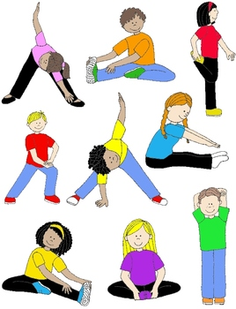

# Defining Obesity (in Adults)

Miss Rachel’s

Classroom Newsletter

### Tips to Promote Physical Activity

Fighting Obesity

Volume 1, Issue 5

Fighting Obesity

# Dear Parents,

## Physical Activity Adventures

* Taking a dog on a walk
* Going on a family walk
* Adventure to the playground
* Family game
  + Mini baseball
  + Soccer
  + Basketball
  + Musical chairs, etc.
* Jump rope
* Gymnastics
* Roller-skating
* Capture the flag
* Tag, water fight, etc.
* Hop scotch
* Swimming
* Bicycling
* Dancing
* Trampolines
* Geocaching (see me for more information)

As we know, physical activity is very important for both the body and the mind.

When we think of physical activity, we typically think of exercising. This may include running, lifting weights, etc. However, physical activity can go so much further than the typical types of exercise; physical activity can even be incorporated within games. Incorporating fun into physical activity proves very effective to children.

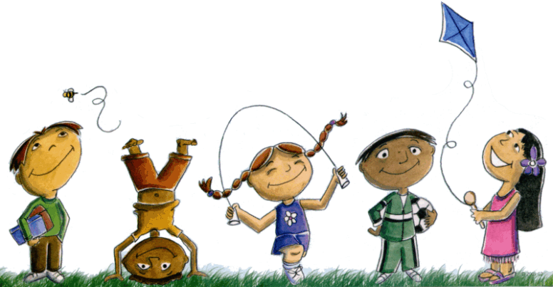

|  |  |
| --- | --- |
| DAILY PHYSICAL ACTIVITY | CALORIE LEVEL OF FOOD PLAN |
| < 30 minutes | 1200 calories |
| 30-60 minutes | 1400 calories |
| > 60 minutes | 1600 calories |

*Please Note: Although ChooseMyPlate provides a calorie level range, calories shouldn’t be stressed. If one is eating healthy foods and a good variety, then the rest will follow.*

<http://fun.familyeducation.com/>

<http://www.gameskidsplay.net/>

<http://pbskids.org/zoom/activities/games/>

<http://jumpbunch.com/kids-click-here/fitness-games/>

Numbers, Counting and Addition

Our unit on value of money is coming to an end and we are now beginning to look at units for measurement, time, and weight. Please keep an eye for opportunities to practice that with your child in day to day life.

## Message to Parents

References:

"Parents and Educators." *ChooseMyPlate*. United States Department of Agriculture, n.d. Web. 12 Nov. 2015.

banner with apples and crayons

# Find Mores Games

References: Thompson, Amy. "Childhood Obesity." *jamanetwork.com*. Web. 25 Aug. 2015.

# Tips to Promote Physical Activity: Volume 1, Issue 5

Hillman, Charles H., Kirk I. Erickson, and Arthur F. Kramer. "Be Smart, Exercise Your Heart: Exercise Effects on Brain and Cognition." Nature Reviews Neuroscience. Macmillan Publishers Limited, Jan. 2008. Web. 8 Nov. 2015.

USD-HHS. "Defining Adult Overweight and Obesity." USA.gov. Web. 27 Apr. 2012.

USD-HHS. "Defining Adult Overweight and Obesity." USA.gov . Web. 27 Apr. 2012.

"Parents and Educators." ChooseMyPlate. United States Department of Agriculture, n.d. Web. 12 Nov. 2015.

Loewenstein, George. "Habit Formation in Children: Evidence from Incentives for Healthy Eating." SSRM . Web. 1 Oct. 2014.

Thompson, Amy. "Childhood Obesity." jamanetwork.com . Web. 25 Aug. 2015.

USDA. "Serving Up MyPlate." choosemyplate.gov . Web. 10 Sep. 2015.

References: Thompson, Amy. "Childhood Obesity." jamanetwork.com . Web. 25 Aug. 2015

# Physical Activity: Volume 1, Issue 4

# Tips to Promote Eating Healthy: Volume 1, Issue 3

# Eating Healthy: Volume 1, Issue 2

# Introduction: Volume 1, Issue 1

Fighting Obesity

banner with apples and crayons

Miss Rachel’s Classroom Newsletter

### Sources

Fighting Obesity

Volume 1, Issues 1-5

Miss Rachel’s Classroom Newsletter

Works Cited

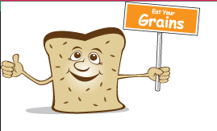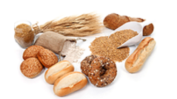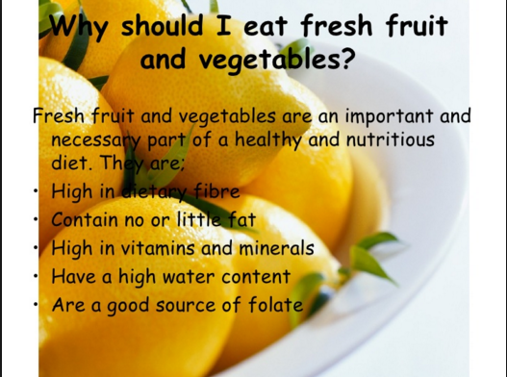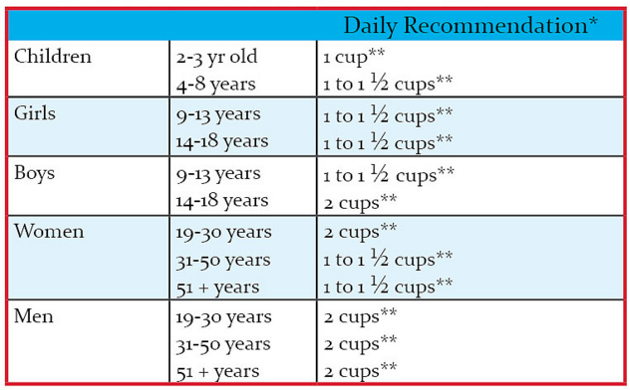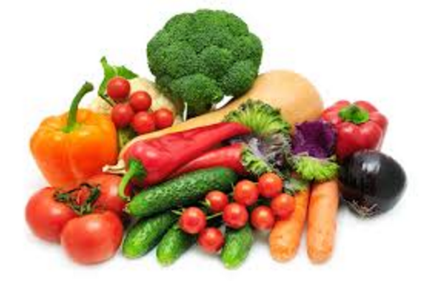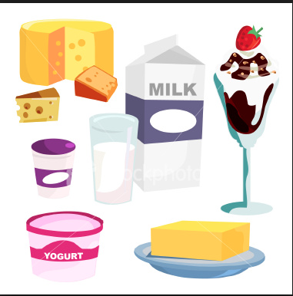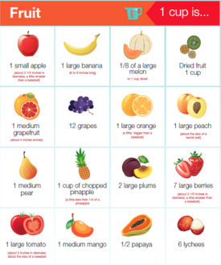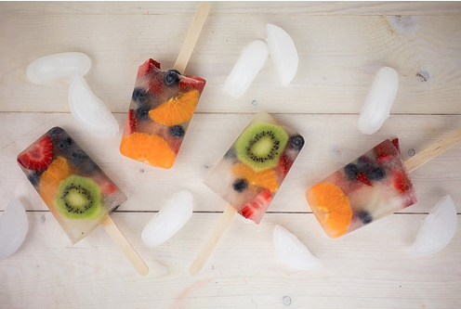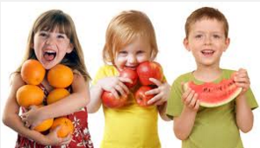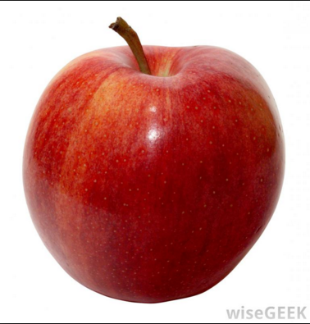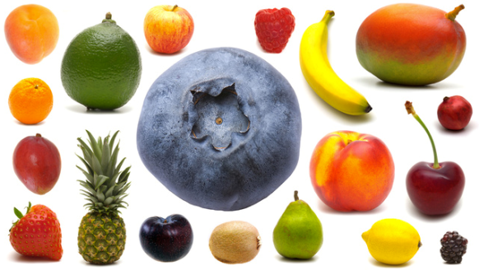

**Nutrition Outside the Classroom**

This is the first installment of a series of five newsletters on the benefits of eating from the five main food groups!

This letter will focus on grains!

**Upcoming up on the Calendar:**

**September 4th:** Parent Open House, students and siblings are also welcome!

**September 12th:** Bring a book! It’s Silent Reading Day, where we will be reading for 20 minutes! Snacks are encouraged!

**October 1st:** Parent Teacher Conferences! Sign up on the class website! Students and siblings are also welcome, games and childcare is available!

Thank you again parents for another wonderful beginning to an already great year! We appreciate everything you do and could not do it without you!

Fiber is good for the body because it helps bodies digest food better!

A serving is generally 1 slice of bread, ½ cup of rice or pasta, and 1 cup of cereal.

Children 4-8 years old should eat about 6 portions of grains and carbohydrates everyday.

Grains are any food that is made from wheat, rice, oats, cornmeal, or barley! It is important to provide both growing and adult bodies with the vitamins and minerals that are found in grains! Grains are carbohydrates, which are the #1 source of energy for a person’s body.

* Grains are full of fiber, which our bodies love!
* Always choose whole grain if possible!

Fabulous First Grade!

Ms. Bennett’s Classroom

Fall 2016

##### How much?

##### Fiber?

##### What counts?

# What are grains?

#### More about grains!

### Welcome!

## Why eat vegetables?

**How many vegetables should we eat?**

Children from the ages of 4-8 years old should eat 1 to 1.5 cups of vegetables a day! The more colorful the vegetable is the better!

* **October 1st: Parent-Teacher Conferences! Remember students and siblings are invited, childcare will be provided free of charge!**
* **October 5st: River Clean-Up, any and all are welcome!**

Important Events

Vegetables are a crucial part of anyone’s diet! They offer us our body’s necessary vitamins and minerals that can prevent cancer, heart disease, stroke, diabetes, and many other diseases caused by aging. The best thing that we can do for our bodies is to feed it lots of vegetables!

# What are Vegetables?

Vitamin D is important for building strong bones in children. Children need strong bones because if they do not have strong bones their bone will have trouble fighting off infections and prevent autoimmune diseases.

**Vitamin D!**

###### Vegetables are the least consumed food groups for most elementary school students. Here at Riverview Elementary School we are trying to change that!

**Dairy**

Choose fat-free or low-fat milk, yogurt, and cheese. If you choose milk or yogurt that is not fat-free, or cheese that is not low-fat, the fat in the product counts against your maximum limit for "empty calories" (calories from solid fats and added sugars).

If sweetened milk products are chosen (flavored milk, yogurt, drinkable yogurt, desserts), the added sugars also count against your maximum limit for "[empty calories](http://www.choosemyplate.gov/what-are-empty-calories)" (calories from solid fats and added sugars).

For those who are lactose intolerant, smaller portions (such as 4 fluid ounces of milk) may be well tolerated. Lactose-free and lower-lactose products are available. These include lactose-reduced or lactose-free milk, yogurt, and cheese, and [calcium-fortified soymilk](http://www.choosemyplate.gov/dairy-calcium-sources) (soy beverage). Also, enzyme preparations can be added to milk to lower the lactose content.

http://www.choosemyplate.gov/dairy#sthash.AdCfTqO8.dpuf

Why dairy?

Milk and dairy products are an important part of a young child's diet. They are a good source of energy and protein, and contain a wide range of vitamins and minerals, including calcium, which growing children and young people need to build healthy bones and teeth.



How much dairy?

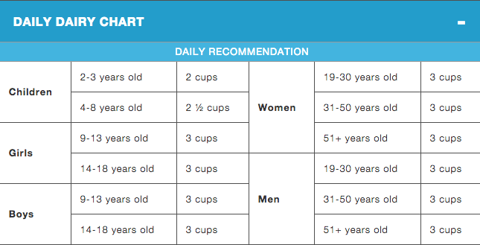

Add cut up fruit to popsicle mold — it’s ok if there are spaces. You don’t want the fruit to be packed too tightly. Pour in coconut water until it reaches the top of each popsicle mold. Freeze the molds overnight, or until solid. Once frozen, remove from mold and serve immediately.

Fruit is incredibly healthy for both growing bodies and people of all ages!

* What foods are in the Fruit Group?
  + Any fresh fruit
  + 100% fruit juice
* Fruits can be canned, frozen, fresh, dried, cut up, or pureed!

What counts as a serving of fruit?

* 1 cup of fruit or 100% fruit juice
* ½ cup of dried fruit
* **individual fruits mostly depend on the size!

Fruit is incredibly healthy for both growing bodies and people of all ages!

* What foods are in the Fruit Group?
  + Any fresh fruit
  + 100% fruit juice
* Fruits can be canned, frozen, fresh, dried, cut up, or pureed!

What counts as a serving of fruit?

* 1 cup of fruit or 100% fruit juice
* ½ cup of dried fruit
* **individual fruits mostly depend on the size!

# Fresh Fruit Frozen Pops

**2-3 Kiwis (peeled)**

**1 pkg. Fresh Strawberries**

**2-3 tangerines (peeled)**

**1 pkg. of blueberries**

**Coconut Water**

**Popsicle Molds**

###### This is a very easy, very healthy alternative to other night time cravings!

# Fruits, Fruits, The Magical Fruit!

###### *Classroom Reminders:*

###### -November 5th: Grandparents Day

###### -November 6th: No School!-Professional Development Day

###### **November is Reading month! Don’t forget to check the classroom website for your day to bring snacks!**

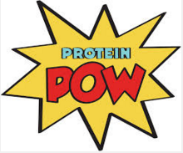

Fall 2016

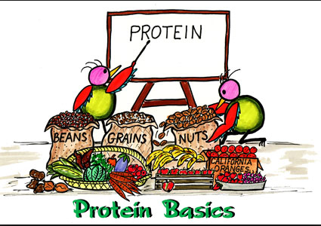

What are proteins?

It’s easy to understand the excitement. Protein is an important component of every cell in the body. [Hair](http://www.webmd.com/skin-problems-and-treatments/picture-of-the-hair) and nails are mostly made of protein. Your body uses protein to build and repair tissues. You also use protein to make enzymes, hormones, and other body chemicals. Protein is an important building block of bones, muscles, cartilage, [skin](http://www.webmd.com/skin-problems-and-treatments/picture-of-the-skin), and [blood](http://www.webmd.com/heart/anatomy-picture-of-blood).

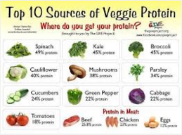

# Proteins

You probably know you need to eat protein, but what is it? Many foods contain protein, but the best sources are beef, poultry, fish, eggs, dairy products, nuts, seeds, and legumes like black beans and lentils.

**Annotated References**

**Annotated Reference One**

**By: Rachel Sanborn**

Dower, Erin. "Top 10 Outdoor Winter Activities." *FamilyEducation*. Sandbox Networks, Inc., 2000-2015. Web. 12 Dec. 2015.

<http://fun.familyeducation.com/slideshow/wintersports/65713.html>.

This website has many different fun activities for families to do with their kids. The specific article I was to refer to; however, covers 10 different outdoor winter activities. With the cold season rolling around, I think that this article may help get parents’ brains racking on things they can get their children involved with this winter. Some of the activities include sledding, snowboarding, ice skating, making snow angles, making snow men, building ice castles, having snowball fights, and more. This site is also neat because, apart from this winter outdoor activity article, it has sections for babies, toddlers, kids, teens, and even in school. These sections encompass great activity and health tips that any parent would find resourceful.

**Annotated Reference Two**

**By: Rachel Sanborn**

Nieboer, Geof. "Kids Games." *Kids Games*. GamesKidsPlay, 8 Oct. 2011.

Web. 12 Dec. 2015. <http://www.gameskidsplay.net/>.

The GamesKidsPlay website is less professional then other websites can be. However, it is a website full of fantastic activities that help kids have fun while staying active. There are tons of games that are easily found under different categories such as “Jump-Rope Rhymes”, “Ball Games”, “Chasing Games”, “Sensing Games”, and more. There is also a “Quick Favorites” section for the most popular activities for children. Some of the quick favorite games include Capture the Flag, Ghost in the Graveyard, Four Square, Marbles, Honey Do You Love Me?, and many more popular games. I think this website is awesome because it’s straight to the point and easy to navigate.

**Annotated Reference Three**

**By: Rachel Sanborn**

"Zoom Games." *Activies from the Show*. PBS Kids, 2010. Web. 16 Dec.

2015. <http://pbskids.org/zoom/activities/games/>.

The PBS Kids game website is a website that pulls games right off of their PBS station for the public to use with easy access. These games have been played by children numerous times and they are loved. The ZoomGames encompasses multiple sections such as “Chasing Games”, “Mind Games”, “Physical Challenges”, “Relay Races”, “Sports Games”, and “Word Games”. Each section has a good amount of game ideas, all which keep children very physically active in the process of the play. This website is popular because it was created by a well-known company and it has a very good reputation. I highly recommend this website for physical activity ideas for children.

**Annotated Reference Four**

**By: Rachel Sanborn**

"Fitness Games." *Jump Bunch: Sports and Fitness for Kids*. JumpBunch,

Inc., n.d. Web. 16 Dec. 2015.

<http://jumpbunch.com/kids-click-here/fitness-games/>.

This website is called jumpbunch. Even from the creative name, you can tell it’s going to be a site full of fun and creative activities for children. I actually used one of the activities from this site and warped it to create one of my lesson plans. I took the game “Cookie Monster” from this website and changed a few words and a few directions in order to create “Super Spartan”. Just as I did, it’s very simple to take a game from a website like this and edit it a small amount in order to better fit your theme or group of children. Aside from the cool games that this site has, they also provide informational readings on benefits and importance of physical activity for kids.

**Annotated Reference Five**

**By: Rachel Sanborn**

"Daily Physical Activities and Games." *Daily Phys Ed*. PedagoNet, n.d.

Web. 16 Dec. 2015. <http://www.pedagonet.com/PhysEd/physed.htm>.

This is a very simple website with learning material and physical activities, as well as games. Many of the activities are for pairs, so this would be a great way to get students involved in physical activity while also bonding with a friend or classmate. One game that I would like to point out is called “Circle Change”. It’s one of the few non-partner games. This can be done with many children at the same time.

Kids are split into two separate teams, each team member is given a number (1, 2, 3…) and there should be an equal number of kids on each team. Two hoops are placed in the middle of the room, and a few beanie bags in each hoop. Each team is on the opposite side of the room as the other. A parent, teacher, guardian then calls out a number. The two students with that number will run to the middle hoops and take one beanie bag and place it in their own end hoop. The game is repeated with different numbers called out and the team with the most beanie bags in their end hoops wins.

I like this game a lot and think that it’s good for building teamwork and teaching patience. There are many other games such as this on this pedagonet website and I recommend any parent, teacher, guardian, etc. looking for physical activities to check it out.