Rachel Sanborn
Date: Monday, 3/18/18 – 10:30am (20-30 minutes)
Subject: Literacy - Vocab Lesson Plan for Navajo Code Talkers
Type: Whole Group / Small Group
Adapted from “Whole Brain Teaching” strategy

This lesson is designed as a vocab intro lesson for this week’s Reading Street Story - Navajo Code Talkers. I have taught this class vocabulary words through adapted Whole Brain Teaching styles a few times this year, so they are familiar with the process and routine. Continuing throughout the week, students will have various outlets to practice the new vocabulary words through journaling, creating a comic with the vocabulary words, Quizlet live, Kahoot, etc.

Materials: Powerpoint pulled up, assigned groups, printed word sheets

3-5 minutes Intro (Setting Expectations) and Transition
- Teacher assigns students in 8 total groups of 3-4.
- Each group has 3-5 minutes to come up with a WBT for the word
- Groups need to:
  - Tell the class the vocab word
  - Tell the class the definition
  - Show us hand signals to help everybody remember (all group members must do same movements – so decide them and practice together)
  - Gestures cannot involve other people or props. (Gestures must be something each person can do alone - so the gestures can’t be something that I need to use other people or props for)
  - Choose a speaker. Everyone else is showing us the hand movements. Elect a group member to speak, and all other group members are doing the hand signals
  - Indoor voice level
- Teacher reveals groups slide (and where groups should go) and hands out word page to each group
https://www.flippity.net/rp.asp?k=17Kz4B3DST-R6jelffU6EKYKjO0ygHNIPXZpgAt4f1KI

3-5 minutes: Students working in groups. Asking teacher if stuck or have questions.

10-15 minutes (1-3 minutes per word TOTAL for both teacher and student time)
Once the 3 minutes are up. Students are asked to sit back at their own spots.
https://docs.google.com/presentation/d/12lzU8vzmO7TnL0q5u1ECrFzgmTU7Clx54DeXosOlkFU/edit?usp=sharing
- With PowerPoint, teacher reads a sentence and shows a picture
  - Students must figure out what word they belong to (less than 1 minute).
- Then that word’s group comes up to teach the WBT they came up with
  - class repeats 3 times (aim for each group in front less than 2 minutes)
- Ask critical questions (use in a sentence, synonym, antonym, etc.)
- Class cheer for group

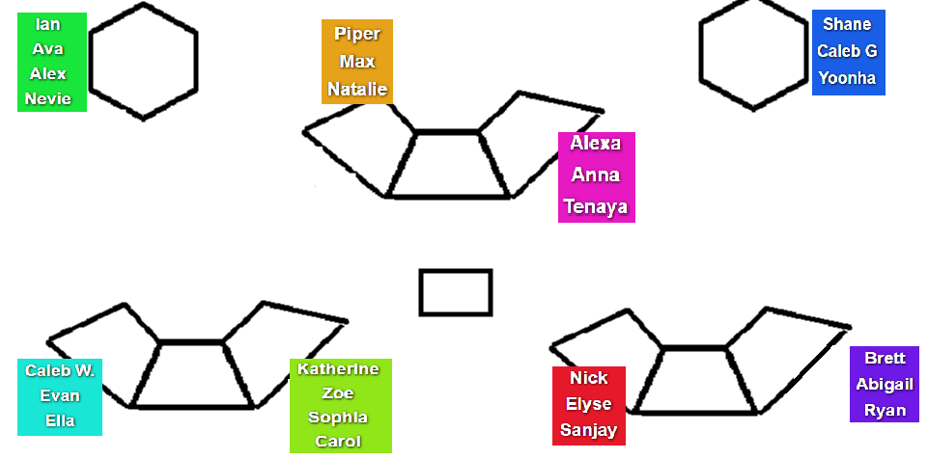

Teaching goals for this lesson based on previous feedback.
- Avoid hand raising - randomly call on
- Choral responses (when my hands drop)
- Give a sentence starter
  - An antonym of advance is _______.
- Written response at end

Vocabulary, Definitions, Example Sentences, and Critical Questions
advance (v, n, adj) → Progress in front of others OR Do something ahead of time.

- The officer planned to advance through the ranks and one day become commander.
- If you study in advance, you will probably do better on the test.

Whole Class: Thumbs up or down - advance or not in advance:
- After you complete a test, your teacher tells you the answers. (not in advance)
- You eat a good breakfast before you go to school. (in advance)
- You get ready for a party by decorating. (in advance)

One Person/Partner Share: Call Random (Critical Q)
- I made advance preparations for my fractions test. What would advance mean here? What could you do in advance for this?
- I prepared in advance for the hockey game. What does advance mean in this sentence?
- What would be an antonym of “advance”? *Use sentence starter
developed (adj, v) → Brought into being

- After we read Voices in the Park, everybody in our class developed their own picture book.
- The Founding Fathers developed the constitution

One Person/Partner Share: Call Random (Critical Q)
- Use developed in a sentence.
exhausting (adj, v) → Making tired

- That soccer game was so long and exhausting.
- Sometimes it’s exhausting when I play tag at recess.

One Person or Partner Share: Call Random (Critical Q)
- What would be a synonym of exhausting? *Use sentence starter
headquarters (n) → Central offices where orders come from

- MSU has its own police headquarters, separate from East Lansing.

One Person/Partner Share: Call Random (Critical Q)
- If you had to name the “headquarters” of the United States of America, what would you say it is? *Use sentence starter
- Where would the “headquarters” of Cornell be? *Use sentence starter

impossible (adj) → Not able to happen

- Before airplanes were invented, people thought it was impossible to fly.

One Person/Partner Share: Call Random (Critical Q)
- Use impossible in a sentence.
intense (adj) → Very strong; extreme

- That basketball game was intense, I was on the edge of my seat the entire time!

One Person/Partner Share: Call Random (Critical Q)
- Without talking, show me with your body/face how you would look/act if you were:
  - In the intense cold
  - intense curiosity
  - Intense heat
  - Intense concentration during a test
messages (n) → information sent from one person to another

- Before technology advanced, it used to be really hard to send messages. But now within seconds, we can send email messages, text messages, Seesaw messages, and more.

One Person/Partner Share: Call Random (Critical Q)
- Before technology advanced, it used to be really hard to send messages. But now within seconds, we can send messages. What type of messages can we send today? (text, email, voice message, note messages in the mail, Seesaw/Facebook, Youtube comment messages, etc).
  - *Use sentence starter: One type of message we send today is….
reveal (v, n) → To make known

- When we play our 2TUT game, I have you all guess who the facts are about before I reveal who the person is.

One Person/Partner Share: Call Random (Critical Q)
- Show, hide, discover, conceal

- Class, when hands drop - You say “antonym” or “synonym”:
  - Is show an antonym or synonym of reveal? (synonym)
  - Is hide an antonym or synonym of reveal? (antonym)
  - Is discover an antonym or synonym of revealed? (synonym)
  - Is an conceal an antonym or synonym of reveal?

Your Name:______________________________________________
GROUP 1 – Navajo Code Talkers Vocabulary Whole Brain Teaching

- Your Task: Teach the class this vocab word using Whole Brain Teaching.
  - Tell us the vocab word
  - Tell us the definition
  - Show us hand gestures to help everybody remember (all group members must do same movements – so decide them and practice together)
  - Gestures cannot involve other people or props. (Gestures must be something each person can do alone; this means you may not create anything that would require people in your group to touch or interact with each other at all – also no props)
  - Choose a speaker. Everyone else is showing us the hand movements. Elect a group member to speak, and all other group members are doing the hand signals
  - Indoor voice level
  - Once you’ve decided your WBT, practice until it’s time to come back together. Practice makes perfect!

Word: advance

Definition: Pro-gress / in front of others /
OR / do something /
ahead of time.

Example Sentences:
- During the race, the person behind me slowly advanced in front of me.
- It’s important to ask your parents in advance, if you want to hang out with a friend.

If you finish planning and practicing your teaching and have extra time, with all group members write as many as you can of your word…
Synonyms: ______________________________________________________

Antonyms: _______________________________________________________

Your Name:______________________________________________
GROUP 2 – Navajo Code Talkers Vocabulary Whole Brain Teaching

- Your Task: Teach the class this vocab word using Whole Brain Teaching.
  - Tell us the vocab word
  - Tell us the definition
  - Show us hand gestures to help everybody remember (all group members must do same movements – so decide them and practice together)
  - Gestures cannot involve other people or props. (Gestures must be something each person can do alone; this means you may not create anything that would require people in your group to touch or interact with each other at all – also no props)
  - Choose a speaker. Everyone else is showing us the hand movements. Elect a group member to speak, and all other group members are doing the hand signals
  - Indoor voice level
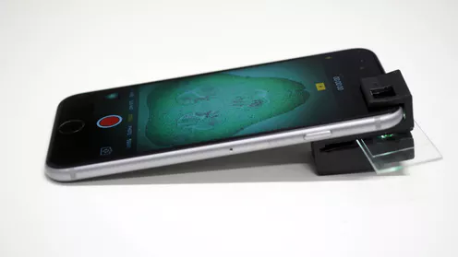
  - Once you’ve decided your WBT, practice until it’s time to come back together. Practice makes perfect!

Word: developed

Definition: brought / into / being

Example sentences:
- Life would be very different if cell phones weren’t developed.

If you finish planning and practicing your teaching and have extra time, with all group members write as many as you can of your word…
Synonyms: ______________________________________________________

Antonyms: _______________________________________________________

Your Name:______________________________________________
GROUP 3 – Navajo Code Talkers Vocabulary Whole Brain Teaching

- Your Task: Teach the class this vocab word using Whole Brain Teaching.
  - Tell us the vocab word
  - Tell us the definition
  - Show us hand gestures to help everybody remember (all group members must do same movements – so decide them and practice together)
  - Gestures cannot involve other people or props. (Gestures must be something each person can do alone; this means you may not create anything that would require people in your group to touch or interact with each other at all – also no props)
  - Choose a speaker. Everyone else is showing us the hand movements. Elect a group member to speak, and all other group members are doing the hand signals
  - Indoor voice level
  - Once you’ve decided your WBT, practice until it’s time to come back together. Practice makes perfect!

Word: exhausting

Definition: make someone / feel / very tired

Example sentences:
- Working out when I play sports can be very exhausting at times.
- Sitting at a desk all day can be exhausting.

If you finish planning and practicing your teaching and have extra time, with all group members write as many as you can of your word…
Synonyms: ______________________________________________________

Antonyms: _______________________________________________________

Your Name:______________________________________________
GROUP 4 – Navajo Code Talkers Vocabulary Whole Brain Teaching

- Your Task: Teach the class this vocab word using Whole Brain Teaching.
  - Tell us the vocab word
  - Tell us the definition
  - Show us hand gestures to help everybody remember (all group members must do same movements – so decide them and practice together)
  - Gestures cannot involve other people or props. (Gestures must be something each person can do alone; this means you may not create anything that would require people in your group to touch or interact with each other at all – also no props)
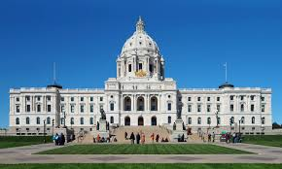
  - Choose a speaker. Everyone else is showing us the hand movements. Elect a group member to speak, and all other group members are doing the hand signals
  - Indoor voice level
  - Once you’ve decided your WBT, practice until it’s time to come back together. Practice makes perfect!

Word: headquarters

Definition: central offices / where orders / come from

Example sentences:
- Sometimes when there is a really important issue, people need to go to the headquarters.
- Most companies have headquarters, and then control little stores in other places.

If you finish planning and practicing your teaching and have extra time, with all group members write as many as you can of your word…
Synonyms: ______________________________________________________

Antonyms: _______________________________________________________

Your Name:______________________________________________
GROUP 5 – Navajo Code Talkers Vocabulary Whole Brain Teaching

- Your Task: Teach the class this vocab word using Whole Brain Teaching.
  - Tell us the vocab word
  - Tell us the definition
  - Show us hand gestures to help everybody remember (all group members must do same movements – so decide them and practice together)
  - Gestures cannot involve other people or props. (Gestures must be something each person can do alone; this means you may not create anything that would require people in your group to touch or interact with each other at all – also no props)
  - Choose a speaker. Everyone else is showing us the hand movements. Elect a group member to speak, and all other group members are doing the hand signals
  - Indoor voice level
  - Once you’ve decided your WBT, practice until it’s time to come back together. Practice makes perfect!

Word: impossible

Definition: not able / to happen

Example sentences:
- It’s probably safe to say that it is impossible for a pig to fly with wings.

If you finish planning and practicing your teaching and have extra time, with all group members write as many as you can of your word…
Synonyms: ______________________________________________________

Antonyms: _______________________________________________________

Your Name:______________________________________________
GROUP 6 – Navajo Code Talkers Vocabulary Whole Brain Teaching
- Your Task: Teach the class this vocab word using Whole Brain Teaching.
  - Tell us the vocab word
  - Tell us the definition
  - Show us hand gestures to help everybody remember (all group members must do same movements – so decide them and practice together)
  - Gestures cannot involve other people or props. (Gestures must be something each person can do alone; this means you may not create anything that would require people in your group to touch or interact with each other at all – also no props)
  - Choose a speaker. Everyone else is showing us the hand movements. Elect a group member to speak, and all other group members are doing the hand signals
  - Indoor voice level
  - Once you’ve decided your WBT, practice until it’s time to come back together. Practice makes perfect!

Word: intense

Definition: very strong / very extreme

Example sentences:
- That workout was so intense!

If you finish planning and practicing your teaching and have extra time, with all group members write as many as you can of your word…
Synonyms: ______________________________________________________

Antonyms: _______________________________________________________

Your Name:______________________________________________
GROUP 7 – Navajo Code Talkers Vocabulary Whole Brain Teaching

- Your Task: Teach the class this vocab word using Whole Brain Teaching.
  - Tell us the vocab word
  - Tell us the definition
  - Show us hand gestures to help everybody remember (all group members must do same movements – so decide them and practice together)
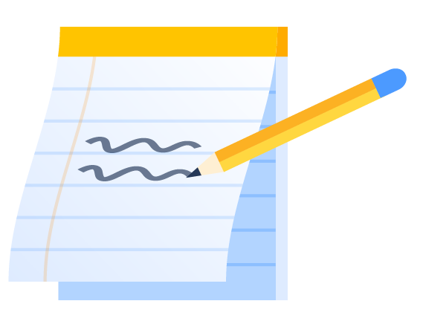
  - Gestures cannot involve other people or props. (Gestures must be something each person can do alone; this means you may not create anything that would require people in your group to touch or interact with each other at all – also no props)
  - Choose a speaker. Everyone else is showing us the hand movements. Elect a group member to speak, and all other group members are doing the hand signals
  - Indoor voice level
  - Once you’ve decided your WBT, practice until it’s time to come back together. Practice makes perfect!

Word: messages

Definition: information / sent from / one
person / to another

Example sentence:
- I know that my mom got a message because her phone just beeped.

If you finish planning and practicing your teaching and have extra time, with all group members write as many as you can of your word…
Synonyms: ______________________________________________________

Antonyms: _______________________________________________________

Your Name:______________________________________________
GROUP 8 – Navajo Code Talkers Vocabulary Whole Brain Teaching

- Your Task: Teach the class this vocab word using Whole Brain Teaching.
  - Tell us the vocab word
  - Tell us the definition
  - Show us hand gestures to help everybody remember (all group members must do same movements – so decide them and practice together)
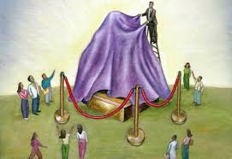
  - Gestures cannot involve other people or props. (Gestures must be something each person can do alone; this means you may not create anything that would require people in your group to touch or interact with each other at all – also no props)
  - Choose a speaker. Everyone else is showing us the hand movements. Elect a group member to speak, and all other group members are doing the hand signals
  - Indoor voice level

Word: reveal

Definition: to make / known

Example sentences:
- I can’t wait for them to reveal the winner!

If you finish planning and practicing your teaching and have extra time, with all group members write as many as you can of your word…
Synonyms: ______________________________________________________

Antonyms: _______________________________________________________

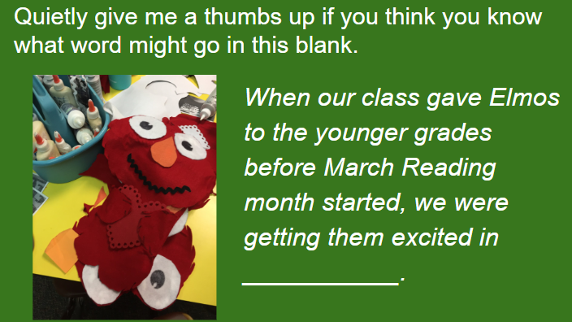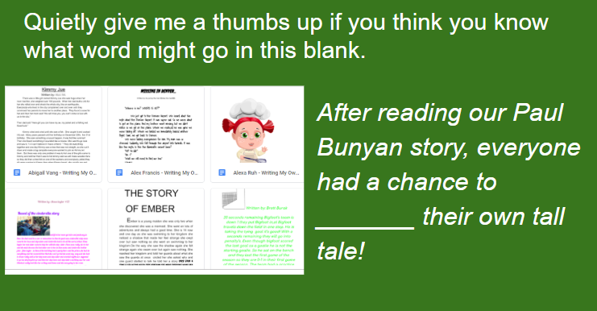
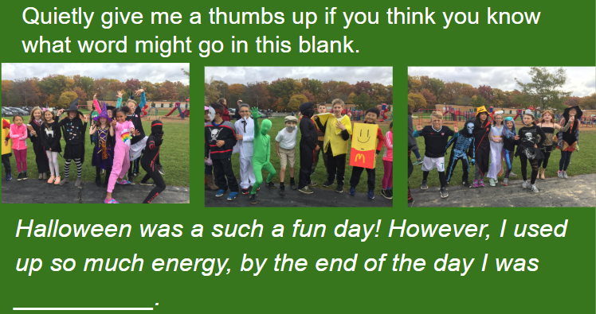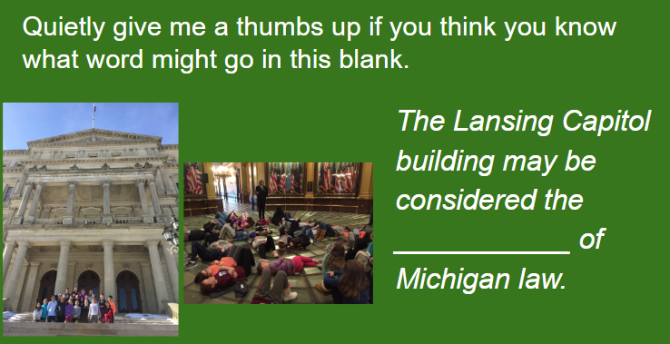
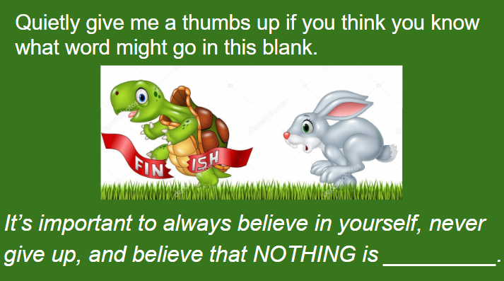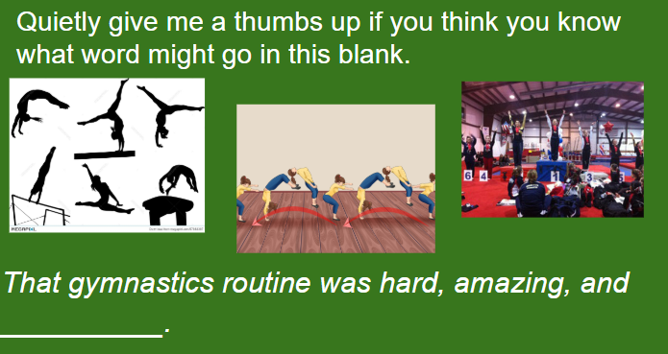
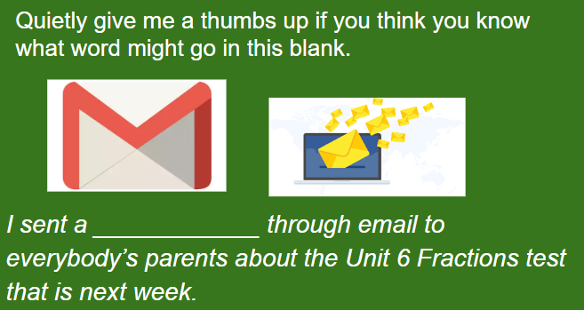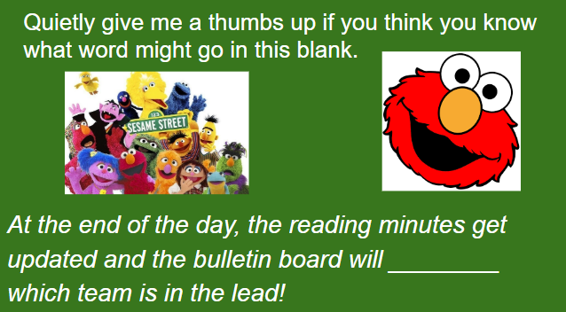

Name:______________________________ Date:_________________
Exit Slip - Navajo Code Talkers Vocabulary
advance (v, n, adj) means… ______________________________________________

Sentence using this word: ______________________________________________
___________________________________________________________________________
Picture:

developed (adj, v) means... ______________________________________________

Sentence using this word: ______________________________________________
___________________________________________________________________________
Picture:

exhausting (adj, v) means... _____________________________________________

Sentence using this word: ______________________________________________
___________________________________________________________________________
Picture:

headquarters (n) means... ______________________________________________
Sentence using this word: ______________________________________________
___________________________________________________________________________
Picture:

impossible (adj) means... ______________________________________________
Sentence using this word: ______________________________________________
___________________________________________________________________________
Picture:

intense (adj) means... ______________________________________________
Sentence using this word: ______________________________________________
___________________________________________________________________________
Picture:

messages (n) means... ______________________________________________
Sentence using this word: ______________________________________________
___________________________________________________________________________
Picture:

reveal (v, n) means... ______________________________________________
Sentence using this word: ______________________________________________
___________________________________________________________________________
Picture:

Name:________________________________
Navajo Code Talkers Vocabulary - Exit Slip Helper
Below are the vocabulary words and definitions. They are not in order. You may use these to help you fill out your own definitions page.
Vocab Words (not in order)  - advance (v, n, adj)  - reveal (v, n)  - developed (adj, v)  - headquarters (n)  - exhausting (adj, v)  - impossible (adj)  - intense (adj)  - messages (n) | Definitions (not in order)  - progress in front of others OR do ahead of time  - brought into being  - making very tired  - Central offices  - can’t happen / not possible  - very strong; very great  - info sent to someone else  - to show

